SUTURA: A Web-Based Tailoring Shop Tracker System



A Capstone Project Proposal
Presented to the Faculty of the
Information and Communications Technology Program
STI College Davao

In Partial Fulfilment
of the Requirements for the Degree
Bachelor of Science in Information Technology

Arabejo, Joshua Wayman A.
Bongo, Jossua A.
Bulotano, Renalyn C.
Masudog, Clareynz June A.

May 2026

ENDORSEMENT FORM FOR PROPOSAL DEFENSE

TITLE OF RESEARCH: SUTURA: A Web-Based Tailoring Shop Tracker System
NAME OF PROPONENTS: Arabejo, Joshua Wayman A.
Bongo, Jossua A.
Bulotano, Renalyn C.
Masudog, Clareynz June A.

In Partial Fulfilment of the Requirements
for the degree Bachelor of Science in Information Technology
has been examined and is recommended for Proposal Defense.

ENDORSED BY:

Jessiel Chris D. Hilot
Capstone Project Adviser

APPROVED FOR PROPOSAL DEFENSE:

Francis Jade M. Solomon
Capstone Project Coordinator

NOTED BY:

Jessiel Chris D. Hilot
Program Head

MAY 2026

APPROVAL SHEET
This capstone project proposal titled SUTURA: A Web-Based Tailoring Shop Tracker System, prepared and submitted by Jossua A. Bongo, Joshua Wayman A. Arabejo, Clareynz June A. Masudog, and Renalyn C. Bulotano, in partial fulfillment of the requirements for the degree of Bachelor of Science in Information Technology, has been examined and is recommended for acceptance and approval.
Jessiel Chris D. Hilot
Capstone Project Adviser
Accepted and approved by the Capstone Project Review Panel
in partial fulfillment of the requirements for the degree of
Bachelor of Science in Information Technology

Ariel P. Lapiñas | Justin Kaye Lolo
Panel Member | Panel Member

Eric P. Ricablanca, MIM
Lead Panelist

Noted:
Francis Jade M. Solomon | Jessiel Chris D. Hilot
Capstone Project Coordinator | Program Head

May 2026

Table of Contents
 |  | Page
Title Page |  | i
Endorsement form for Proposal Defense |  | ii
Approval Sheet |  | iii
Table of Contents |  | iv
Introduction |  | 1
 | Project Context | 1
 | Purpose and Description | 3
 | Objectives | 5
 | Scope and Limitations  Review of Related Literature/Studies/Systems | 7  11
Methodology |  | 16
 | Requirements Gathering | 18
 | Requirements Analysis | 20
 | Requirements Documentation | 22
 | Technical Background  Design of Software, System, Product, and/or Processes | 38  42
References |  | 58
Appendices |  | 60
 | Resource Persons | 123
 | Personal Technical Vitae | 124

Introduction

Project Context
Digital visibility is critical for traditional tailoring businesses. Local consumers often struggle to find specialized tailors due to a lack of centralized business profiles and fragmented market information. Centralized tracking systems featuring localized mapping and clear apparel categorization help bridge this gap, making digital integration essential for modern tailoring practices.
Globally, the bespoke garment industry is undergoing a digital transformation as consumers shift away from mass-produced fast fashion toward personalized apparel (Statista, 2025). This evolving craft has become a highly competitive sector of commerce. Consequently, tailoring enterprises worldwide are rapidly adopting web-based storefronts and software-as-a-service (SaaS) frameworks to secure a digital presence in key urban hubs.
In the Philippines, this digital shift is reflected in national directives urging micro, small, and medium enterprises (MSMEs) to adopt online tools to match modern consumer behavior (DTI, 2024). Although the demand for uniforms, formal wear, and corporate attire is consistently high, the local garment industry remains fragmented. Philippine tailoring shops lack centralized digital ecosystems to display their work, creating a disconnect between tech-savvy Filipino consumers and traditional shop owners.
Despite the growing demand for custom garments in Davao City, consumers continue to face significant challenges in locating the right tailoring shop for their specific needs. There is currently no centralized digital platform where customers can search for tailoring services by garment type such as Filipiniana, Barong Tagalog, or school uniforms and immediately see all available shops within their area. This forces customers to rely on word-of-mouth recommendations or physically travel across different districts of the city just to find a tailor that specializes in their required garment. This fragmented discovery process leads to wasted time, missed revenue opportunities for local tailors, and reduced customer satisfaction.
These manual setups cause critical operational challenges, leading to unnecessary travel and miscommunication for customers trying to verify shop capabilities. This visibility gap results in prolonged search times, missed revenue opportunities for local tailors, and reduced customer satisfaction during peak seasons. Fragmented data also makes it difficult for shop owners and system administrators to evaluate marketplace trends, generate performance reports, or monitor active subscriptions.
Studies confirm that centralized discovery and tracking platforms are vital for service-driven industries. Localized mapping systems significantly improve consumer engagement by providing immediate access to branch locations and operating hours (Mapme, 2024). Additionally, automated notifications and transparent tracking features build consumer trust and optimize retention when embedded into service workflows (Zendesk, 2024).
To resolve these challenges, this project proposes SUTURA: A Web-Based Tailoring Shop Tracker System. The system integrates subscription-based tier management, localized branch mapping, specialized apparel categorization, and dynamic order progress tracking. This system is designed to support both consumer-facing search inquiries and structured tailoring shop workflows, increasing digital market visibility while providing a data-driven discovery experience.

Purpose and Description
Many traditional tailoring shops still rely on manual, fragmented methods to maintain business visibility and handle consumer inquiries. Service specializations are rarely cataloged online and location details are shared inconsistently through phone calls or word-of-mouth, often resulting in prolonged search times and double appointmet during peak seasons. While these offline approaches may suffice for small-scale local markets, they ultimately lead to missed revenue opportunities for tailors and reduced discovery satisfaction for customers.

To address these issues, this project proposes the development of SUTURA: A Web-Based Tailoring Shop Tracker System. The system is designed to provide system administrators, shop owners, and customers with a centralized network that simplifies and organizes shop discoverability and service tracking. Instead of relying on disconnected offline methods, SUTURA integrates localized branch mapping, specialized apparel categorization, subscription tier management, and dynamic order tracking into a single system.

SUTURA operates through a tier-based subscription offering Basic, Pro, and Premium plans that allows tailoring shop owners to register their business and manage multiple branches based on their selected tier. The system supports storefront customization, branch location mapping, apparel specialization management, and automated order status tracking through a unified tailoring shop dashboard. By restricting public visibility and premium features to active subscribers, the system ensures a verified, organized, and reliable marketplace for consumers.

For daily tracking, SUTURA provides a centralized Tailoring Shop Management Dashboard that enables tailoring shop owners to manage active customer inquiries, update shop branches, and monitor order progress in real time. Shop staff can update the stages of garment fulfillment such as cutting, sewing, and ready for pickup while recording basic consumer transaction details for subscription performance metrics. All updates are instantly synchronized across the system, ensuring that customers receive real-time visibility regarding their order status and verified shop availability.
The system also includes a web-based public discovery platform tailored for customers. Users can search for local tailoring shops, filter businesses by specific apparel specializations, view real-time branch locations on an interactive map, and read verified customer reviews. Additionally, customers can monitor their ongoing garment fulfillment status in real time and receive automated notifications, ensuring a transparent, convenient, and reliable transaction process from discovery to pickup.

To ensure platform quality and reliability, SUTURA implements a strict pre-verification process for all newly registered businesses. Upon creating an account, shop owners must first undergo a thorough review and approval process by the system administrator before gaining any access to the system or its internal dashboard features. This approach guarantees that only fully verified and legitimate tailoring establishments can configure shop settings, access internal management workflows, and ultimately appear on the public marketplace and interactive map interface.

Objectives
To centralize and digitize the discoverability and service tracking of tailoring shops within Davao City by providing integrated tools for location-based shop discovery, tier-based subscription management, real-time order progress monitoring, and data-driven business analytics, ultimately improving both the tailoring shop's digital visibility and the customer's service experience
Specifically, this study aims to:
- Administrative Dashboard for subscription monitoring, the system administrator will manage tailoring shop registration approvals, validate apparel categories, verify branch map locations, and oversee platform-wide activity and system performance.
- Subscription and Account Management for tiered plan enrollment, the tailoring shop will register on the system, select from Basic, Pro, and Premium subscription plans, manage role-based staff access, and maintain active subscription validity for continued platform visibility.
- Shop Discovery and Map-Based Navigation Module for location and garment-based search, the customer will search for tailoring services by specific garment type, filter results by area, specialization, and real-time branch availability, view pinned geolocation coordinates of verified tailoring shops within Davao City, and access complete storefront profiles and route directions.
- Tailoring Shop Dashboard for storefront management, the shop owner will configure their digital profile, manage service catalogs and apparel specializations, set itemized pricing, handle appointment schedules, and control their public platform visibility.
- Order Tracking and Measurement Module for real-time production monitoring, the tailoring staff will record and retrieve digital customer measurements, manage appointment-based order intake, and update garment production stages, while customers monitor their order progress from placement to pickup.
- Interactive Analytics Dashboard for data-driven reporting, the system administrator and tailoring shop owners will generate real-time visual reports on subscription activity, monthly sales revenue, outstanding customer balances, and individual shop productivity.

Scope and Limitations
Scope of the Study
The scope of this study covers the development and implementation of SUTURA: A Web-Based Tailoring Shop Tracker System, designed to streamline shop discoverability and service visibility through an integrated platform within Davao City's local garment sector. The system supports four primary user roles, namely the system administrator, tailoring shop owners, tailoring staff, and customers, by utilizing a centralized subscription-based network that integrates tier-based shop management, localized branch mapping, specialized apparel categorization, and dynamic order progress tracking.

The system includes an Administrative Dashboard that enables system administrators to review and approve tailoring shop verification requests before system access is granted, oversee active shop profiles, and validate custom apparel categories. It also monitors tier-based subscription billing, verifies submitted branch map locations, and generates real-time platform performance reports.
The Subscription and Account Management enables tailoring shop owners to register their businesses and select from tiered service plans Basic, Pro, and Premium based on their operational needs, subject to administrator pre-verification. Each subscription enforces role-based access boundaries, allowing active tailoring shop owners to curate shop profiles, manage service catalogs, and maintain digital storefronts.

For customers, the system provides a Shop Discovery and Map-Based Navigation Module that integrates pinned geolocation coordinates to display administrator-approved tailoring shop branches within Davao City. This module features garment-based and location-based filtering, allowing users to search by specific garment type, filter by area or specialization, and view real-time branch availability. Through this unified interface, clients can access complete shop profiles, operational schedules, itemized pricing, and route directions to selected tailoring shop branches.

The system provides a Tailoring Shop Dashboard built for storefront management, allowing them to configure their digital profiles, manage service catalogs, and declare apparel specializations. This module supports setting itemized pricing configurations, handling customer appointment schedules, and controlling public platform visibility to effectively manage their digital presence on the system.

The module also supports appointment-based order intake where tailoring staff can create job orders directly from scheduled fittings. Customers can monitor the real-time production status of their garments and receive automated SMS or email notifications at each stage transition, from placement to final pickup.

The Interactive Analytics Dashboard aggregates platform-wide and shop-level data to generate real-time visual reports for both system administrators and shop owners. Administrators can monitor subscription activity, total registered shops, and platform revenue trends, while shop owners can track monthly sales performance, outstanding customer balances, individual staff productivity, and order completion rates.

Limitations of the Study
This study is limited to software-based operational functionalities and does not include direct integration with physical hardware systems, manufacturing machinery, or automated textile equipment.
The system requires a stable internet connection for all functionalities including real-time order tracking, measurement record access, appointment scheduling, subscription processing, notification delivery, and analytics generation. SUTURA does not support offline data processing or background synchronization, meaning all dashboard operations and real-time updates are unavailable without an active network connection.
The system does not support hardware integration such as automated body-scanning devices, RFID tags, or digital measuring tools. All customer clothing measurements must be manually encoded by authorized users into the digital repository.
The payment module tracks transaction details and deposits but does not include native integration with third-party payment gateways for direct fund transfers. External financial reconciliation and banking settlement verification are outside the scope of the system.
The reporting module is limited to operational and performance-based summaries and does not include predictive analytics, AI-driven forecasting, or advanced business intelligence. Furthermore, notification delivery depends on third-party services which may result in occasional delays.
The tracking of utility costs such as electricity bills and equipment maintenance is not included as the system focuses primarily on service production and order fulfillment rather than full-scale overhead accounting.
The management of employee payroll including salary calculations and attendance-based wage distribution is outside the functional scope of the system .
The system focuses strictly on service tracking and order fulfillment, completely excluding inventory tracking, material stock monitoring, and purchase order management. Consequently, all supplier-related processes, fabric procurement, and material stock logistics fall entirely outside the system boundary and must be handled independently by the tailoring shop through external means.
The system does not include tax filing automation or business permit validation. It is restricted to managing the internal workflows of tailoring businesses operating within the SUTURA ecosystem.
The system completely excludes logistics, courier routing, and physical delivery management. All garment handovers, order pickups, and shipping arrangements fall outside the system boundary and must be handled directly between the tailoring shop and the customer through external methods.

REVIEW OF RELATED LITERATURE/STUDIES
Tailoring management challenges are well documented in research. Ospina-Agudelo (2024) conducted a mixed-methods study on bespoke tailoring consumer expectations. The study gathered digital behavior analytics from hundreds of active customers. Findings revealed that manual tracking causes significant market visibility loss. Fragmented apparel categorization and absent storefront profiles compound these visibility issues. The author argued that tailors need purpose-built platforms for shop discovery and service tracking. This data-driven research relied on multi-criteria decision-making models to analyze practicing customers. However, the study remained purely exploratory. It did not propose or test any specific digital software solution. This leaves a critical gap that SUTURA is designed to address.
Building on this, Wu et al. (2022) examined manual operational bottlenecks within localized garment networks. Their study found that fragmented, paper-based logs severely diminish the overall customer experience. Outdated methods cause systemic miscommunications regarding customer profiles and fabric types. Furthermore, manual shops face high administrative friction during peak production seasons. This research focuses deeply on internal workspace flaws and advocates for digitized governance models. Meanwhile, Ospina-Agudelo (2024) provides a complementary view regarding external consumer visibility demands. Together, both sources demonstrate that problems exist simultaneously on the customer and tailoring shop sides. Customers expect digital accessibility that manual storefront infrastructure simply cannot provide. Neither source proposes a unified system solving marketplace discovery and internal shop tracking concurrently. This combined problem is exactly what SUTURA is built to resolve.
Workflow and progress tracking represents another critical area validating the need for integrated web solutions. Lapuz (2022) studied the effects of migrating physical logs to a web-based Database Management System. This system utilized a three-tier architecture and the Rapid Application Development methodology. Transitioning to this digital framework drastically accelerated internal business data velocity. The system effectively minimized operational data loss for small-scale retail operators. Furthermore, interactive analytics dashboards allowed business owners to monitor real-time sales and productivity. This provided strong evidence that centralized tracking technology successfully eliminates enterprise inefficiencies. However, the tested system was a general administrative retail tool. It completely lacked the specific sub-modules required for customized garment businesses. It could not store complex body dimensions or track tailoring workflows. SUTURA addresses this limitation by integrating a specialized order and measurement repository.
User acceptance and system usability are fundamental to implementing digital trackers in local communities. Berris (2022) analyzed a Web-Based Membership Tracking Information System using open-source technologies. This research employed the Scrum framework and the ADDIE model to evaluate user experiences. Evaluation was completed through the standardized System Usability Scale. The study found that non-technical staff achieved exceptionally high satisfaction scores. Usability increased dramatically when complex digital databases replaced tedious pen-and-paper logging. Customized applications held a measurable operational advantage over manual environments by preventing inconsistencies. However, this local research was strictly restricted to a martial arts member lifecycle. It did not account for localized branch mapping or specialized apparel workflows. This remains a gap because tailoring operations rely heavily on geographical discoverability. SUTURA addresses this by combining intuitive open-source architecture with localized branch map verification. This configuration ensures high usability while fully catering to the local garment sector.

Review of Related Systems (RRS)
Virtual Cloth Fitting Try-On Network (VCFN) allows users to virtually test garment fits. Its architecture relies heavily on deep learning models and UNet generator layers. The system maps clothing deformation using complex thin-plate spline transformations. VCFN mathematically aligns physical clothing metrics to specific human body vectors. This extreme simulation accuracy effectively minimizes the necessity for physical fittings. However, the system requires immense computing power and specialized graphics hardware. This creates an immediate operational barrier for traditional, low-resource shops. Furthermore, the software focuses strictly on AI graphics simulations. It completely lacks functional back-office business administration modules. SUTURA resolves this gap by providing a lightweight, cloud-based tracking workflow.
Tailor Brands Platform coordinates small business identities and branded corporate merchandise. Its structure features an automated graphic engine linked to a cloud dashboard. This platform provides highly responsive interfaces optimized for non-technical users. This simplified layout sets an excellent usability benchmark for traditional artisans. However, the software focuses primarily on graphic branding and asset continuity. It lacks granular system control for complex, custom tailoring workflows. The system does not host dedicated customer body dimension repositories. It provides no mechanism to monitor real-time production within workshops. SUTURA addresses this by shifting focus to physical artisan tracking mechanics.
The Bespoke Tailor Hub Tracker replaces manual ledger books for boutique retail spaces. Its architecture reflects a standard web-based three-tier design pattern, processing custom order reservation data through real-time operational status filters. The system automatically accumulates monthly commercial sales data and fabric processing updates for internal shop management, effectively balancing rapid system response times with strict data security protocols. However, the application remains restricted to basic, high-level order logging functions. It is entirely incapable of handling custom, item-level apparel tracking, and the underlying database cannot log complex customer anatomical measurement fields. It offers no technical method to track individual garments across physical workshop production phases, such as cutting and sewing. SUTURA directly addresses this gap by adapting this status-tracking logic specifically for sequential, multi-stage bespoke garment production.
The Open-Source Tailoring Shop Tracker automates structural profile tracking for local dressmaking associations. This software relies on standard relational database management structures and achieved high marks on the standardized System Usability Scale, proving that intuitive, minimalist web configurations can easily accommodate non-technical tailoring staff. Furthermore, the system's role-based security module securely preserves customer dimension data profiles over long periods. However, its functional scope is restricted to non-commercial, localized organization tracking. It completely excludes transactional accounting logs, fabric stock depletion alerts, and multi-tier supplier ordering engines. The system also lacks any map-based business discoverability or online scheduling tools for external consumers. SUTURA solves these combined limitations by pairing a highly usable, accessible interface with specialized, end-to-end commercial tracking features.

Synthesis
The four reviewed systems demonstrate that functional tailoring management software exists across a range of operational areas including basic order logging, customer profile preservation, user interface configuration, and virtual fitting. The Virtual Cloth Fitting Try-On Network (VCFN) provides a strong body-vector simulation with deep-learning configurations but completely lacks back-office business administration, customer dimension records, and internal tracking modules. The Tailor Brands Platform offers highly responsive interfaces suited for small brand setup but restricts itself strictly to graphic continuity and corporate assets, entirely lacking physical workshop tracking and customer measurement matrices. The Bespoke Tailor Hub Tracker provides solid high-level order logging and data security protocols but cannot process item-level garment changes, log complex customer anatomical measurement fields, or monitor sequential phase updates. The Open-Source Tailoring Shop Tracker delivers basic profile tracking optimized for non-technical staff but excludes transactional accounting logs and online appointment scheduling.
None of the four systems provides a unified technical workflow that brings together client-accessible appointment scheduling, precise anatomical measurement logging, and multi-stage garment production tracking in a single platform. None of them also provides a map-based interface that allows clients to visually locate registered tailoring shop branches near them, which is a practical feature for first-time clients who are looking for local artisan workshops. These consistent gaps across all reviewed systems establish the functional need for SUTURA, which is designed to integrate all of these workflows into one platform with role-appropriate interfaces for administrators, tailoring shop owners, tailoring staff, and customers.
Features / Functional Requirements | VCFN | Tailor Brands Platform | Bespoke Tailor Hub Tracker | Open-Source Tailoring Tracker | SUTURA
Client-Accessible Appointment Scheduling | ✖ | ✖ | ✖ | ✖ | ✔
Precise Anatomical Measurement Logging | ✔ | ✖ | ✖ | ✔ | ✔
Multi-Stage Garment Production Tracking | ✖ | ✖ | ✖ | ✖ | ✔
Map-Based Local Shop Discoverability | ✖ | ✖ | ✖ | ✖ | ✔
Back-Office Business Administration | ✖ | ✔ | ✔ | ✖ | ✔
Transactional Accounting Logs / Analytics | ✖ | ✖ | ✔ | ✖ | ✔
Intuitive UI for Non-Technical Staff | ✖ | ✔ | ✖ | ✔ | ✔
Low-Resource Hardware Requirements | ✖ | ✔ | ✔ | ✔ | ✔
Table 1: Existing Studies/Systems & Their Gaps

METHODOLOGY
The development of SUTURA adopts a Developmental Research Approach using the Agile Software Development Life Cycle (SDLC). This approach is highly suitable for the proposed system because it manages a complex architectural framework divided into multiple specialized modules, such as Shop Discovery, Order Tracking, and Interactive Analytics. Since SUTURA is designed to bridge the functional gaps in existing systems by unifying map-based shop visibility and secure measurement versioning, the Agile methodology provides the necessary flexibility to refine these unique features through iterative cycles.
The development process is broken down into specific sprint cycles, with each cycle producing a working version of the system’s features. Rather than building everything at once, each module is designed, tested, and polished before moving to the next. This iterative approach allows for constant feedback and improvements, making it easier to adjust to new requirements. The Agile sprint cycle followed in the development process is illustrated in Figure 3.
The project starts by gathering data through interviews and observations with tailoring shop owners, tailoring staff, and customers. The researchers examine current manual tasks like plotting physical order receipts, documenting customer dimensions, and managing manual appointment schedules to identify common problems and inefficiencies. This information establishes the foundation for the system's technical and functional requirements, ensuring the software directly addresses the specific needs of the local tailoring business.
The project moves into planning and design by organizing the gathered features into a prioritized backlog based on their importance and technical needs. The system is then modeled using use case diagrams, BPMN workflows, activity diagrams, sequence diagrams, database design, and user interface prototypes. These technical blueprints serve as a detailed guide for development, ensuring every part of the system stays aligned with the project goals.
During the actual development phase, the system is built through consecutive sprints, starting with the setup of secure login credentials and role-based access for system administrators, tailoring shop owners, and workshop staff. Subsequent cycles focus on building the core subscription tier tools alongside the localized garment discovery and search module to handle digital shop filtering by location. Later sprints introduce the interactive map-based interface for branch visibility within Davao City, the customer appointment scheduling system, and the automated notification modules. The specialized order tracking and measurement module is then constructed to let staff log unique body profiles and update physical production stages, while giving clients real-time visibility from placement to pickup. Finally, the centralized interactive analytics dashboard is integrated to provide real-time reports on sales revenue, outstanding customer balances, and platform activity.
To maintain high quality, the researchers perform continuous testing during every sprint. Each feature is tested individually and as part of the whole system to ensure everything works correctly. Selected tailoring shop owners, staff, and clients then participate in User Acceptance Testing (UAT) to check if the system is easy to use and helpful for their daily tasks. The feedback from these tests is used to fix issues and improve the software in the next sprint, making the final platform reliable and practical.
Once the sprints are complete, the system is launched in a cloud environment for easy access. After deployment, the researchers continue to monitor the system to fix bugs, improve speed, and ensure data security. Regular maintenance and future updates are also scheduled based on user feedback to keep the system efficient and up to date for tailoring shops and their customers.

Requirement Gathering
The requirements gathering for SUTURA: A Web-Based Tailoring Shop Tracker System involved a comprehensive data collection process utilizing semi-structured interviews, direct on-site observations, and market-gap analyses within the local tailoring industry of Davao City. The researchers engaged with both tailoring shop owners (representing potential platform subscribers) and local consumers to map out the current fragmented discovery process and identify critical operational bottlenecks.
The preliminary assessment of the local tailoring sector in Davao City revealed that current operations rely almost entirely on fragmented, manual processes and isolated physical documentation. Customer exploration and shop discovery happen strictly through word-of-mouth recommendations or physical foot traffic, leaving traditional tailors without any unified digital storefront visibility. This disconnected setup creates severe operational and market challenges for both shop owners and consumers.
The traditional tailoring shop's management acts as the centralized hub for all administrative and operational tasks, from taking initial physical measurements to manually trying to maintain local market visibility. Relying on a single person or a small team to handle consumer inquiries and order fulfillment especially during high-demand peak seasons for school uniforms, formal wear, and corporate attire creates massive operational strain. This heavy manual workload and reliance on fragmented data often lead to severe miscommunication between shop owners and consumers trying to verify shop capabilities or track active orders.
The assignment of production tasks and overall order fulfillment workflows within the local tailoring industry are currently managed through informal, experience-based methods. Order tracking typically relies on manual record-keeping and memory, meaning progress monitoring is entirely dependent on immediate staff awareness rather than a structured digital workflow tracker. Without a centralized digital ecosystem to monitor garments across sequential production stages, shop owners face significant operational friction. This lack of transparent tracking features makes it exceptionally difficult to communicate progress to consumers or manage high volumes of custom apparel requests such as Filipiniana, Barong Tagalog, and school uniforms especially during peak seasons.
Difficulties in managing production timelines and tracking active orders were identified as a critical, recurring issue within the local tailoring industry. Because operational data is currently managed across scattered, manual setups and physical documentation, tracking errors frequently occur. This makes it highly challenging for shop owners to handle multiple high-priority orders simultaneously while keeping their actual shop capabilities up to date. This fragmented data environment prevents system administrators and shop owners from effectively evaluating marketplace trends or generating accurate performance reports.
Significant consumer-facing limitations were identified within the current ecosystem, primarily driven by a lack of digital visibility and fragmented market information. Under the existing manual setups, local consumers completely lack access to automated notifications or transparent, real-time status updates regarding their garment’s progress. Furthermore, tech-savvy consumers have no centralized platform to execute specialized apparel categorization or visually locate nearby services. This forces clients to rely entirely on word-of-mouth recommendations or undergo the inconvenient process of physically traveling across different districts of Davao City just to verify a shop's capabilities.
To address these operational gaps and market fragmentation, SUTURA: A Web-Based Tailoring Shop Tracker System is designed as a centralized platform that streamlines tailoring workflows while providing a data-driven discovery experience for consumers. To bridge the disconnect between tech-savvy Filipino consumers and traditional shop owners, the system integrates a specialized apparel categorization module, allowing customers in Davao City to search for specialized custom garments such as Filipiniana, Barong Tagalog, or school uniforms and filter results by specific garment types. It embeds a localized branch mapping interface to provide immediate visual access to branch locations and operating hours across different districts, successfully eliminating unnecessary travel and prolonged consumer search times. For structured shop workflows, SUTURA features a dynamic order progress tracking module coupled with automated customer notifications to build trust, optimize retention, and eliminate miscommunication during peak seasonal surges.

Requirements Analysis
Within the Software Development Life Cycle (SDLC), the requirements analysis phase is essential for pinpointing and establishing the precise needs of both the users and the software. For the proposed system, this stage concentrates on eliminating the bottlenecks associated with traditional, manual tailoring workflows by designing a unified, automated digital tracking and discovery platform.
The system involves four primary user roles: system administrators, tailoring shop owners, tailoring staff, and customers. System administrators manage shop registration approvals, validate custom apparel categories, verify branch map locations, and monitor platform-wide activity and subscription compliance. Meanwhile, tailoring shop owners and staff configure digital profiles, set itemized service pricing, coordinate appointment schedules, version customer measurements, and track production workflows. Finally, customers browse verified storefront profiles, execute garment-based filtering, schedule service-related bookings, and track their garment production progress in real-time.
The system operates within a web-based environment accessible through standard web browsers. Shop owners and tailoring staff primarily access the system via desktop interfaces for comprehensive workshop management and structural data entry, while the system features a mobile-responsive design for customers. This allows clients to search for tailoring services, utilize the map-based interface, and monitor their order progress remotely from their mobile devices. The system is specifically designed for use within the physical premises of registered tailoring shops in Davao City, as well as remotely by their respective clients.
The system must support key functional requirements, including a map-driven shop discovery matrix and an automated production tracking module. Timing and triggers are central to the system’s operation: automated notifications are triggered instantly when a client books an appointment or when a garment transitions to a new production stage, such as cutting, stitching, fitting, or ready for pickup. Furthermore, business reports and analytics are generated dynamically, providing system administrators with metrics on subscription activity and shop owners with immediate, real-time insights into monthly sales revenue, outstanding customer balances, and individual staff productivity. The system supports flexible billing through deposit tracking and cash or digital gateways, integrated with a SaaS-based subscription tier module Basic, Pro, and Premium for efficient visibility management.
Non-functional requirements include reliability, security, usability, and scalability. The system shall maintain high uptime benchmarks, execute automated database backups every 24 hours, securely protect sensitive customer measurements, and ensure an intuitive user experience for non-technical staff evaluated through standard usability metrics. It is deployed in a cloud-based environment to provide high availability and real-time synchronization, allowing the system to handle multiple tailoring enterprises in Davao City efficiently.
In conclusion, this analysis ensures that Sutura is strategically aligned with the users' needs and the specific working environment of the local tailoring industry, providing a strong roadmap for the subsequent design and technical implementation of the system.

Requirement Documentation

- Functional Model
The functional model presents the major functions of Sutura using use case diagrams. These diagrams identify the actors and system sub-modules that interact with the platform to support end-to-end operations. The core components and modules analyzed across this model include the Administrative Module, Shop Owner Module, Tailoring Staff Module, and Customer Module, which collectively drive the functional workflows of Subscription and Account Management, Shop Discovery and Search, the Map-Based Interface, Order Tracking and Measurement, and the Appointment Booking Module.

The first use case diagram represents the Administrative Module. The Admin is the sole actor in this module and is directly connected to four primary use cases. Through Login, the administrator gains authenticated access to the platform. Through Monitor Subscription, the administrator oversees the subscription lifecycle and active statuses of all registered shops within the system. Through Manage Accounts, the administrator handles platform-level user profiles, which automatically incorporates Manage Plan via an include relationship to control feature access. Lastly, through Manage Registration, the administrator reviews, approves, or rejects incoming shop applications. Together, these use cases establish the administrator as the central authority responsible for maintaining platform governance, managing system plans, and validating all tenant registrations. (Refer to Page (61) for Figure (2))

The third use case diagram represents the Tailoring Staff Module. The Tailoring Staff is the primary actor in this module, which focuses on internal workshop tasks and order execution. Through Login, staff members authenticate into their dedicated portal to access their dashboard workspace. Through Manage Measurement, the tailoring staff takes, logs, or updates customer physical body dimensions directly within the system. Lastly, through Manage Progress, staff members handle the multi-stage garment fabrication process, which automatically incorporates Update Status via an include relationship to ensure that any physical production milestone instantly syncs across the platform. Together, these use cases establish the tailoring staff as the core actor responsible for executing garment production, maintaining measurement records, and updating order status flags throughout the tracking lifecycle. (Refer to Page (63) for Figure (3))

The third use case diagram represents the Shop Owner Module. This module involves the Shop Owner as the primary actor, interacting with four main use cases to manage internal shop profiles and business configurations. Through Login, the shop owner authenticates into the platform to gain dashboard access. Through Manage Shop Profile, the owner sets up and maintains storefront visibility. Through Manage Staff Account, the owner administers employee credentials and system access, which automatically incorporates Manage Role via an include relationship to enforce proper access control boundaries. Lastly, through View Dashboard Analytics, the owner monitors real-time sales performance metrics, tenant activities, and tracking statuses. Together, these use cases empower the shop owner with centralized administrative oversight over their workforce, digital storefront, and operational analytics. (Refer to Page (62) for Figure (4))

The fourth use case diagram represents the Customer Module. This module involves the Customer as the primary actor, alongside the external Google Maps API. The customer interacts with four core use cases to navigate the platform and manage transactions. Through Login, the customer authenticates to access personalized dashboard features. Through Search and Filter Shop, the customer browses available tailoring services, which includes an extend relationship to Track Order allowing them to view progress if an active order exists. Through View Map Interface, the customer accesses location features, which directly utilizes the external Google Maps API to render interactive geographical data. Lastly, through Book Appointment, the customer reserves a service slot with their selected shop. Together, these use cases establish the customer as an active user interacting with external mapping resources to easily locate, book, and track bespoke tailoring services. (Refer to Page (63) for Figure (5))

The fifth use case diagram represents the Subscription and Account Management Module, coordinating platform onboarding and tier governance between two primary actors: the Shop Owner and the System Admin. The Shop Owner initiates platform onboarding through Register Shop Account, which automatically captures mandatory Shop Details and triggers Select Subscription Plan via include relationships. This plan selection dynamically extends to the Basic Plan, Pro Plan, or Premium Plan based on the business's choice, and directly links to Process Subscription Payment for billing activation. To establish operational workflows, the Shop Owner also uses Create Tailoring Staff Accounts, which includes Assigning Tailoring Staff Roles for workforce permissions. On the administrative side, the System Admin manages platform structures via Manage Subscription Tiers and reviews submissions through Review Shop Application, a process that strictly includes a mandatory Verify Business Credentials step. A fraudulent or incomplete application extends to Reject Application, whereas a valid submission extends to Authorize Account Access, which subsequently extends to Send Temporary Credentials SMS/Email to complete tenant provisioning. Together, these structural use cases create a secure, automated gateway for business admission and service plan enforcement. (Refer to Page (64) for Figure (6))

The sixth use case diagram represents the Shop Discovery and Search Module, facilitating streamlined tenant discovery and storefront exploration between the Customer as the primary actor and the System. The workflow initiates when the Customer utilizes Search Tailoring Shop, which automatically incorporates Display Search Results via an include relationship to present an initial matching directory. To optimize this directory, the Customer can choose to Filter Shops By Location, which carries an include relationship to Display Nearby Shops to provide geographically relevant selections. From the filtered results, the Customer interacts with Select Shop Profile to inspect granular business records; this action automatically triggers View Service, Pricing, and Location Details to ensure comprehensive service transparency before final decision-making. Finally, the process culminates when the customer moves forward with transaction pathways, where the profile interface dynamically extends into either Place Order or Book Appointment based on their chosen engagement route. (Refer to Page (64) for Figure (7))

The seventh use case diagram represents the Map-Based Interface Module, which provides geographical visualization and spatial tools by linking the Customer as the primary actor with the external Google Maps API. The workflow begins when the Customer interacts with View Shop Location, which sends a query that automatically includes Display Pinned Coordinates to render the exact placement of tailoring stores on a visual canvas. Both of these operations rely directly on the external Google Maps API subsystem to process real-time geospatial information and project the interactive map elements. Once the shop's pin is visible, the interface exposes an included sub-process to Provide Directions, enabling the customer to instantly pull navigational tracking steps. This pathway ultimately extends into Navigate to Shop, allowing the customer to physically transition from digital route planning to in-person shop arrival. (Refer to Page (65) for Figure (8))

The eighth use case diagram represents the Order Tracking and Measurement Module, which orchestrates the complex lifecycle of bespoke garment fabrication across four primary actors: the Customer, Tailoring Staff, Shop Owner, and the external Payment Gateway API. The workflow begins on the customer's side, where selecting an order type can branch into an Online Order or a physical Appointment Order. An online order requires Customer Login to allow Select Garment and Size/Measurement, whereas an in-person appointment routes directly to the workshop, where the Tailoring Staff executes Manage Body Measurement. Once inputs are gathered, the system handles an automated Calculate Estimated Pick-Up Date step. The Customer then proceeds to Process Payment, which links directly to the external Payment Gateway API for transaction handling. Upon payment verification, the system creates a job profile for the Shop Owner to execute Review Order Feasibility, which branches via extend relationships into Reject Order (triggering an Issue Automatic Refund and Send Cancellation SMS sequence) or Approve Order. An approved order moves back to the workshop floor, where the Shop Owner triggers Allocate Materials and Labor, and the Tailoring Staff begins Fabricate Custom Garment. Once fabricated, the garment undergoes a mandatory Quality Assurance Check. Defective items extend to Perform Tailoring Adjustments, while passing items trigger Update Tracking Status to Ready for Fitting and prompt an automated Send Ready for Fitting SMS to the customer. Finally, the Customer utilizes Attend Fitting Session, which can extend into Perform Garment Alterations if adjustments are needed, or proceed to Settle Final Payment Balance and Receive and Rate Finished Garment to successfully close the order tracking lifecycle. (Refer to Page (66) for Figure (9))

The ninth use case diagram represents the Appointment Module, which coordinates service scheduling and client management between two primary actors: the Customer and the Shop Owner. The workflow begins on the consumer side, where the Customer utilizes Select Tailoring Shops and Search Tailoring Shops to identify business targets before initiating the scheduling sequence via Book Appointment. To complete a booking reservation, the system enforces two mandatory include relationships: collecting Customer Info, Purpose, Date & Time and running an automated Check Availability routine against the shop's active ledger. Once a reservation request is logged, it can branch dynamically via extend relationships if the user needs to Cancel Appointment or Request Reschedule. On the provider side, the Shop Owner undergoes Login to manage backend operations, actively using Manage Shop Schedule to control operational blocks and handling incoming client requests via Authorize Appointment. Upon a booking authorization decision, the process automatically extends to Trigger SMS Notification to dispatch a confirmation alert directly back to the customer's mobile device. (Refer to Page (67) for Figure (10))
II. Process Model
The process model documents the core workflows of Sutura through Business Process Model and Notation (BPMN) diagrams. Six operational modules are modeled, with each process represented by a diagram illustrating the proposed Sutura workflow.
The proposed Administrative Module workflow is organized across two primary lanes: the System Administrator and the System. The process begins when the administrator logs in and the system authenticates the account credentials. Once successfully verified, the administrator can select from four distinct operational paths: Accounts, Plans, Registration, or Monitor. Choosing Accounts or Plans allows the administrator to manage tailoring accounts or update subscription features, with changes automatically saved to the database by the system. If Registration is selected, the administrator reviews, accepts, or declines pending sign-ups, which prompts the system to dispatch an automated SMS or email notification. Selecting the Monitor path triggers parallel system tracks that concurrently evaluate subscription lifecycles, system overviews, and overall performance to display real-time analytics. After completing any module task, the administrator can either return to the dashboard to execute another process or log out to securely terminate the session. (Refer to Page (67) for Figure (11))
The proposed Subscription and Account Management Business Process Model and Notation (BPMN) diagram maps out the multi-tenant onboarding workflow across three distinct pools: the Shop Owner, the System, and the System Admin. The process initiates in the Shop Owner pool when a merchant triggers the start event by filling out the shop registration form, selecting an applicable subscription plan, and submitting the request. This actions a message flow into the System pool, which automatically creates a pending merchant profile and flashes a notification event to the System Admin. The System Admin then performs a user task to verify the submitted shop registration documents. The workflow evaluates this verification through an exclusive gateway: if the credentials are valid, the admin approves the registration, instructing the System to update the storefront status to active, initialize the multi-tenant workspace, and securely send temporary credentials to the merchant, allowing the Shop Owner to execute a final task to log in and change their password, successfully terminating the onboarding loop at an active state end event; if the credentials are invalid, the admin rejects the registration, causing the System to log the refusal details, execute an automatic payment refund task, and dispatch a rejection notice to the applicant, leaving the Shop Owner at a rejected state end event with the data-driven choice to re-apply. Together, these structured message flows, service gateways, and role boundaries replace manual verification steps with a highly secure, completely transparent, and automated tenant admission pipeline. (Refer to Page (68) for Figure (12))
The proposed Shop Discovery and Search Module process diagram is organized across two lanes: the Customer and the System. The process begins when the customer opens the Sutura platform and searches for tailoring shop services, prompting the system to display the initial search results. The customer can then filter these results, allowing the system to update and show the refined list of tailoring shops. From this list, the customer selects and views specific shop profiles to review details such as services, pricing, and location. If the customer is interested, they proceed directly to placing an order or booking an appointment; if not, they are routed back to the shop list to continue browsing. This workflow replaces traditional, fragmented search methods with an integrated digital discovery process that streamlines shop comparison and user engagement. (Refer to Page (68) for Figure (13))
The proposed Map-Based Interface process diagram is organized across two lanes: the Customer and the System. The process begins when the customer opens the map interface to view tailoring shop locations. The system then displays the pinned geolocation coordinates of the shops and provides access to navigation directions. Finally, the customer follows the generated directions to locate the selected tailoring shop. This workflow replaces traditional, unguided navigation with an integrated geolocation mapping system that improves local shop accessibility and user convenience. (Refer to Page (68) for Figure (14))
The proposed Order Tracking and Measurement Module process diagram spans four lanes: the Customer, the System, the Tailoring Staff, and the Shop Owner. The process initiates when a customer chooses an order type; online orders go through system login authentication, garment selection, and measurement input, whereas physical appointments bypass this to let tailoring staff take or update body measurements directly. Once order details are validated and submitted, the system updates the status to pending payment, calculates an estimated pick-up date, and processes the customer's payment before generating a job order profile for the shop owner’s review. If the shop owner finds the order unfeasible, the system processes a refund and sends a cancellation notice; if approved, the system evaluates staff workloads, allocates materials, and distributes the order to the tailoring staff for garment fabrication. Following a strict quality check and any necessary staff adjustments, the system updates the status to be ready for fitting and alerts the customer via SMS. The customer then attends the fitting prompting an alteration loop if they are unsatisfied or finalizes the pick-up by settling any remaining balance, allowing the system to verify the final payment, issue a digital receipt, and complete the workflow once the finished garment is received and rated. (Refer to Page (69) for Figure (15))
The proposed Appointment Booking Module process diagram is organized across three lanes: the Customer, the System, and the Shop Owner. The process begins when a customer browses and selects an available tailoring shop to create an appointment, filling in their personal information, preferred date and time, purpose, and measurement details before submitting the request. The system validates the selected timeslot and routes the request to the shop owner, who reviews the details and checks for available tailoring staff. If a staff member is available, the shop owner approves the request, prompting the system to send an automated confirmation SMS to the customer. If staff is unavailable, the shop owner logs the reason and suggests an alternative time, which the system dispatches as a reschedule notice via SMS; the customer can then either choose to pick a new time returning them to the appointment creation step—or decline, resulting in a cancellation notice that concludes the workflow. This process transitions manual appointment coordinating into a digitally validated, real-time scheduling and communication system. (Refer to Page (69) for Figure (16))
- Data Model
The Sutura structural model defines the platform's static architecture by mapping its primary object classes, localized attributes, and logical associations. To represent real-world tailoring and multi-tenant operations comprehensively, the domain model is organized into five specialized modules: Administrative, Subscription and Account Management, Order Tracking and Measurement, and Appointment. By establishing strict behavioral boundaries, data encapsulation, and class multiplicities, these diagrams construct the foundational object-oriented blueprint required to support data consistency and guide the system's integrated backend architectural logic.

The Administrative Module domain diagram outlines SUTURA’S identity and authorization structure by mapping the key classes required for platform accountability. The User class serves as the core component, managing access profiles through structural attributes including username, password, email, system role, and account operational status. It maintains a one-to-many relationship with the AuditLog class, meaning a single user can systematically trigger multiple system log instances over time. The AuditLog class captures these behavioral trails by tracking the precise action_type, a contextual description of the modification, and an exact execution timestamp. This setup establishes the structural foundation for role-based authentication and security oversight, ensuring all backend activities are transparently monitored across the platform. (Refer to Page (85) for Figure (31))

The Subscription and Account Management domain diagram illustrates SUTURA's framework for managing tenant tiers and shop profiles by defining the core classes responsible for system monetization. The SubscriptionPlan class acts as the baseline blueprint, storing configuration attributes such as plan_name, billing_cycle, and price. It maintains a one-to-many relationship with the ShopSubscription class, which records specific registration runs through its start_date, end_date, and execution status parameters. Crucially, the Shop class which contains tenant records including shop_name, physical address, mapping coordinates, and verification_status shares a one-to-many relationship with the subscription log. This structural link establishes a relational bridge, ensuring that each storefront profile is explicitly tracked against its active financial tier benefits and operational constraints across the platform. (Refer to Page (85) for Figure (32))

The Order Tracking and Measurement Module domain diagram outlines SUTURA’s primary workshop operations by defining the core classes that manage custom garment fabrication and payment collection. The schema is anchored by the central JobOrder class, which coordinates workflow lifecycle fields such as status, total_cost, due_date, and created_at. It relies on a series of structural interactions across the system: the CustomerProfile places the order and provides specific data stored in the Measurement class, while the Shop receives the order, manages available catalog items via the Service class, and assigns tasks to the TailoringStaffProfile. Furthermore, each transactional unit requires a Payment entry for tracking business earnings, updates material tracking logs via OrderMaterial, and receives performance reviews through the Feedback class. This setup ensures unified tracking logic, allowing the platform to maintain high operational integrity from client dimensions to final product delivery. (Refer to Page (86) for Figure (33))

The Appointment Module domain diagram outlines SUTURA’s scheduling framework by defining the core classes responsible for managing client-to-merchant bookings. The schema is centered around the Appointment class, which serves as the operational hub by structuring scheduling properties such as schedule_date, purpose, and reservation status. It relies on straightforward one-to-many relationships across the module: the CustomerProfile class which contains client details like first_name, last_name, and phone_number holds a structural link to manage individual user bookings. Simultaneously, the Shop class representing the tailoring storefront with attributes like shop_name, address, coordinates, and verification_status acts as the hosting entity. This clean configuration ensures unified validation rules, allowing the system to track real-time calendar reservations directly against distinct storefront operations without structural bloat.(Refer to Page (86) for Figure (34))
III Behavioral Model

Activity Diagrams
The activity diagrams describe the step-by-step flow of actions, decision points, and parallel processes within each module of Sutura. Each diagram is analyzed by identifying its swimlanes, the actors or components within each lane, the sequence of tasks, and the logic of decision gateways that determine how the flow branches and converges throughout the process. This structural breakdown formally maps out the behavioral architecture of the system, illustrating how user interactions seamlessly translate into backend processing and automated data updates.
The proposed Administrative Module activity diagram is organized across two lanes, the System Administrator and the System, beginning when the administrator accesses SUTURA and logs in for system credential authentication. Once successfully verified, the administrator enters the admin dashboard and can choose between four core paths: Accounts, Plans, Registration, or Monitor. Opting for Accounts or Plans allows the administrator to toggle tailoring account statuses or update plan features, which the system automatically saves and updates in the database. Selecting Registration permits the administrator to review, accept, or decline pending applications, prompting the system to dispatch an automated SMS or email notification to the shop owner. Choosing the Monitor path triggers parallel system tracks that concurrently evaluate subscription lifecycles, system overviews, and overall performance, routing these metrics directly to an analytics view. After completing any module task, the administrator can return to the main dashboard to execute another operation or log out to securely conclude the session. (Refer to Page (70) for Figure (17))

The proposed Subscription and Account Management Business Process Model and Notation (BPMN) diagram maps out the multi-tenant onboarding workflow across three distinct pools: the Shop Owner, the System, and the System Admin. The process initiates in the Shop Owner pool when a merchant fills out the registration form, selects a subscription plan, and submits the request. This action sends a message flow into the System pool, which automatically creates a pending merchant profile and sends a notification event to the System Admin. The System Admin then performs a user task to verify the submitted shop registration documents. The workflow evaluates this verification through an exclusive gateway: if the credentials are valid, the admin approves the registration, instructing the System to update the storefront status to active, initialize the multi-tenant workspace, and securely send temporary credentials to the merchant, allowing the Shop Owner to execute a final task to log in and change their password, successfully terminating the onboarding loop at an active state end event; if the credentials are invalid, the admin rejects the registration, causing the System to log the refusal details, execute an automatic payment refund task, and dispatch a rejection notice to the applicant, leaving the Shop Owner at a rejected state end event with the option to re-apply. (Refer to Page (71) for Figure (18))
The proposed Shop Discovery and Search Business Process Model and Notation (BPMN) diagram maps out the discovery workflow across two operational pools: the Customer and the System. The process initiates in the Customer pool when a user triggers the start event by inputting specialized search parameters such as explicit apparel categories or target locations—into the tracking layout. This action sends a message flow into the System pool, which executes a service task to query the database and visually returns a localized map grid of nearby tailoring businesses matching the criteria. The Customer then selects a specific storefront to inspect its business profile, pricing tables, and available specialty crafts. The workflow evaluates the customer's intent through an exclusive gateway: if the user is satisfied, they proceed directly to the next milestone loop by initiating an order placement or scheduling a shop booking, successfully terminating the search pipeline at an active completion end event; if they are unsatisfied, they are routed immediately back to browse the active map directory. Refer to Page (72) for Figure (19))

The proposed Map-Based Interface activity diagram is organized across two lanes: the Customer and the System. The process begins when the customer opens the map interface and requests to view a specific tailoring shop location. The system handles this request by showing and displaying the pinned geolocation coordinates on the map interface. From there, the system provides access to the precise directions leading to the tailoring shop. Finally, the customer follows the provided direction guide to navigate to the physical shop, successfully concluding the workflow. (Refer to Page (73) for Figure (20))
The proposed Order Tracking and Measurement Module activity diagram is organized across four lanes: the Customer, the System, the Tailoring Staff, and the Shop Owner. The process begins when a customer selects an order type; online orders prompt system credential validation to allow garment selection and size/measurement input, while physical appointment orders bypass login authentication, routing directly to the tailoring staff to take or update body measurements. Once the system validates the inputs, it concurrently updates the status to pending payment and calculates an estimated pick-up date before the customer completes the payment step, which triggers the system to generate a job order profile for the shop owner's feasibility review. If the shop owner rejects the order, the system handles an automatic refund and sends a cancellation notice; if approved, the shop owner evaluates workloads, allocates materials, and passes the order to the tailoring staff for garment fabrication. Following fabrication, the garment undergoes a quality check where failing items are routed for staff adjustments and passing items prompt a status update to ready for fitting alongside an automated customer SMS notification. Finally, the customer attends the fitting triggering an alteration loop if unsatisfied or proceeds to finalize the pick-up by settling any remaining balance, allowing the system to verify the final payment, issue a digital receipt, and successfully close the tracking workflow once the customer receives and rates the finished garment. (Refer to Page (75) for Figure (21))
The proposed Appointment Booking Module activity diagram is organized across three lanes: the Customer, the System, and the Shop Owner. The process begins when a customer opens the platform to browse tailoring shops and checks availability; if a shop is unavailable, the customer returns to browsing, but if available, they choose to create an appointment by inputting personal info, preferred date/time, purpose, and measurement details. The system then validates the selected timeslot and forwards the application to the shop owner for review. If the shop owner finds no available tailors, they log a reason and suggest a new time, prompting the system to send an automated reschedule notice via SMS so the customer can either accept returning them to select a new timeslot or decline, which prompts a cancellation SMS that ends the session. If the shop owner approves the request, the system instantly logs the confirmation, triggers an automated approval SMS to the customer, and securely completes the scheduling workflow. This centralized process replaces manual coordination with verified, real-time booking and direct multi-channel communication tracks. (Refer to Page (76) for Figure (22))
The Tailoring Shop Management Activity Diagram outlines the control flow for a Shop Owner configuring their business storefront within the SUTURA system. The process initiates with a login attempt where the system validates user credentials; failing this loops the owner back to the login screen, while successful authentication grants access to the Tailoring Shop Dashboard. Upon selecting the Storefront Module, the owner can concurrently navigate multiple configuration paths including configuring their digital profile, managing service catalogs, setting itemized pricing, handling appointment schedules, controlling shop visibility, and managing apparel specializations. Once these storefront adjustments are finalized, the system saves the configurations, updating both the database records and the user interface. The workflow concludes with a decision gate allowing the owner to either continue managing their storefront or proceed to log out, successfully terminating the session. (Refer to Page (77) for Figure (23))

Sequence Diagrams

The sequence diagrams for SUTURA detail the chronological flow of interactions between actors, the user interface, the backend system, and the database during core operations. Each diagram utilizes vertical lifelines to represent participants and horizontal arrows to map the specific sequence of messages exchanged. Together, these diagrams establish the foundational execution paths for data routing, state transition tracking, and role-based access validation across the multi-tenant tailoring network.

The first sequence diagram illustrates the Administrative Dashboard workflow, outlining SUTURA's control loop for managing tenant onboarding and verification through message exchanges between platform layers. The workflow begins when the System Administrator opens the dashboard interface, prompting the Admin Dashboard UI to request pending registrations from the SUTURA System, which fetches the records from the Database. After reviewing the shop's apparel categories and branch location metrics, the administrator submits an approval or rejection decision. This action triggers the system to update the shop's account status in the Database and return a real-time visual confirmation to the dashboard interface. (Refer to Page (78) for Figure (24))
The second sequence diagram illustrates the Subscription and Account Management workflow, mapping the chronological interactions between the Shop Owner, Registration UI, SUTURA System, and the Database. The process initiates when the Shop Owner registers a shop account, inputs essential business details, and selects a targeted tier through the interface, prompting the SUTURA System to commit an initial profile record to the Database under an inactive state configuration. Once this baseline layout is saved, the Shop Owner completes the subscription payment, sending a real-time validation call through the Registration UI that triggers the backend system to activate the subscription plan and log the updated tier status in the Database. Upon rendering an active plan confirmation on the screen, the Shop Owner can securely create internal staff accounts and assign platform roles. This access metadata is systematically processed by the SUTURA System to store the final, personalized staff profiles in the Database, completing the onboarding pipeline with role-based system boundary. (Refer to Page (79) for Figure (25))
The third sequence diagram illustrates the Shop Discovery and Search workflow, mapping the chronological interactions between the Customer, Marketplace UI, SUTURA System, and the Database. The process initiates when a customer searches for tailoring services and applies targeted search criteria including garment varieties, geographical locations, and design specializations directly within the user interface. The Marketplace UI forwards this search request to the SUTURA System, which executes an optimized query against the Database to look up and return a filtered array of matching tailoring establishments back to the presentation layer. Upon viewing the filtered results, the customer triggers an explicit action to open a specific shop profile. This prompts the interface to request detailed storefront information from the backend system, which performs a secondary fetch operation to retrieve the shop's individual service catalogs, itemized pricing structures, and community reviews from the Database before rendering the full merchant information screen to the user. (Refer to Page (80) for Figure (26))
The fourth sequence diagram illustrates the Map-Based Interface workflow, mapping the chronological interactions between the Customer, Map Interface UI, SUTURA System, and the Database. The process begins when a customer opens the map-based interface, prompting the Map Interface UI to request verified shop locations from the SUTURA System, which queries the backend to fetch branch coordinates directly from the Database. Once this location metadata is returned, the system displays the active shop pins within the interactive map. The customer can then narrow their selection by filtering shops by area, causing the UI to pass the chosen geographical bounds to the SUTURA System, which queries matching branches and returns the filtered subset to dynamically update the visible map pins. The workflow culminates when the customer selects a specific shop pin and requests directions, prompting the interface to process the routing parameters and render the final navigation details to the physical tailoring shop on-screen. (Refer to Page (81) for Figure (27))
The fifth sequence diagram illustrates the Tailoring Shop Dashboard workflow, mapping the chronological interactions between the Shop Owner, Shop Dashboard UI, SUTURA System, and the Database. The process begins when the Shop Owner accesses the workspace to manage their storefront, executing immediate actions to update their digital profile, manage service catalogs, declare design specializations, and configure itemized pricing structures through the user interface. The Shop Dashboard UI bundles these changes and submits the configuration to the SUTURA System, which processes the transaction to update and save the core business profile and service data in the Database before rendering the updated storefront layout back to the user. Following this, the owner handles active appointment schedules and toggles the shop’s public marketplace visibility settings. The interface commits these final scheduling and visibility changes to the backend system, which updates the merchant's settings inside the Database and returns a real-time success confirmation to ensure all operational preferences are immediately synchronized. (Refer to Page (82) for Figure (28))
The sixth sequence diagram illustrates the Order Tracking and Measurement workflow, mapping runtime interactions between the Customer, Tailoring Staff, Shop Owner, Order Tracking UI, SUTURA System, and Database. The process begins when a customer configures a job order and schedules a fitting appointment on the UI, prompting the system to log a pending record in the Database. Once the Shop Owner reviews and approves the request, the system updates the order to an active state. During the fitting session, the Tailoring Staff records customer dimensions, which the system saves securely. As production advances, the staff logs progress adjustments, triggering the system to update the Database and send real-time milestone notifications to the client until the final pickup alert is dispatched. (Refer to Page (83) for Figure (29))
The seventh sequence diagram illustrates the Interactive Analytics Dashboard workflow, mapping the data retrieval and visualization process between the Admin or Shop Owner, Analytics Dashboard UI, SUTURA System, and Database. The process begins when the user opens the workspace and selects a report type, prompting the UI to request business intelligence datasets. The system aggregates historical records from the Database and processes these data streams to compute interactive charts and performance metrics on the UI. Finally, the user can drill down to review specific operational insights such as multi-tenant subscription activity, monthly revenue, outstanding balances, and staff productivity which triggers the system to fetch the latest database records and refresh the dashboard layout. (Refer to Page (84) for Figure (30))

Technical Background
- Technologies to be Used
The development of SUTURA: A Web-Based Tailoring Shop Tracker System, will utilize modern, accessible, and industry-relevant technologies aligned with current standards in web application development. The system will adopt a client-server architecture, enabling centralized data management and multi-user access for tailoring shop owners, workshop staff, and clients through a single unified platform. The system will be fully responsive, ensuring optimal usability across desktop computers, tablets, and mobile browsers without requiring a separate mobile application.
The system will utilize Next.js, React, and TypeScript to build a dynamic and strictly-typed frontend. This stack, paired with Tailwind CSS, ensures a professional and fully responsive interface that adapts seamlessly to any screen size. To manage complex data flows and ensure a smooth user experience, Zustand will be utilized for efficient, lightweight state management across all system modules.
On the backend, the system will utilize Laravel (PHP) to manage all server-side operations, including business logic, user authentication, role-based access control, and data processing. Laravel will expose RESTful APIs to facilitate seamless communication between the frontend interface and the server, ensuring efficient and real-time data exchange across all core system modules such as order progress tracking, measurement repositories, and subscription processing workflows.
For data storage, MySQL will serve as the primary relational database management system, providing a structured and reliable schema for managing customer profiles, body measurements, job orders, billing records, appointment schedules, and transaction history. MySQL is well-suited for Sutura's operations as it supports structured relational data, which is essential for securely linking specific customer profiles to their unique physical dimensions and sequential order tracking milestones.
The database will be hosted on PlanetScale, a scalable cloud-based MySQL hosting platform, ensuring data availability, security, and remote accessibility without the need for on-premise server infrastructure.
For deployment, the frontend application will be hosted using Vercel, a cloud hosting platform optimized for modern web applications, while the Laravel backend and its API services will be deployed on Railway or Render. These platforms ensure that the system remains accessible online throughout the development and testing phases of the project.
For the development environment, the team will use Visual Studio Code as the primary code editor due to its extensive support for PHP, JavaScript, and the frameworks used in this project.
GitHub will be utilized for version control and collaborative development, allowing team members to manage, track, and merge code changes efficiently throughout the development lifecycle.
Postman will be used to test and validate all RESTful API endpoints, ensuring system reliability, data integrity, and consistent performance before integration.
Additionally, Figma will be used for designing user interface wireframes and interactive prototypes prior to development, serving as the visual and structural blueprint for all system screens, user flows, and design components.

- Calendar of Activities
The calendar of activities outlines the planned timeline for the documentation phase of SUTURA: A Web-Based Tailoring Shop Tracker System. Since this study is currently in the Capstone Project 1 phase, the activities covered are limited to the planning, research, analysis, and design stages of the system.
The Gantt chart presents a summary of all documentation activities alongside their corresponding duration and period of execution. Color indicators are used to represent the status of each activity — BLUE indicates an activity that has been started but is not yet finished, while YELLOW indicates an activity that is currently in progress or has been completed. (Refer to page (94), Figure (44))

Resources
- Hardware
This section outlines the essential hardware and software resources needed to develop, test, and deploy the SUTURA. These resources ensure the smooth development and implementation of the system based on the chosen technologies. The hardware requirements for SUTURA encompass the necessary electronic elements for the development and testing of the system. This includes a computer device with at least an Intel Core i3 or AMD Ryzen 3 processor, 4GB RAM, and 128GB SSD or 500GB HDD storage, running on Windows 10. A stable internet connection is required to support cloud services, API integration, and system accessibility. (Refer to Page (60) for Table (2))
- Software
The software resources utilized in the development of SUTURA consist of industry-relevant tools aligned with modern web application standards. Next.js, React, and TypeScript are used for building the dynamic and strictly-typed frontend interface, while Tailwind CSS ensures a professional and fully responsive layout across all screen sizes and devices. Zustand is utilized for efficient client-side state management across all system modules. On the backend, Laravel (PHP) handles all server-side operations including business logic, user authentication, role-based access control, and API management through RESTful endpoints. MySQL serves as the primary relational database management system, providing a structured and reliable schema for storing and managing all system data including customer profiles, job orders, records, and transaction histories. (Refer to Page (61) for Table (3))

Design of Software, System, Product, and/or Processes
- Database Design
The database design of SUTURA is engineered to provide a structured, secure, and scalable data storage architecture for the multi-tenant tailoring business management system. Utilizing a relational database model, system data is organized into interconnected tables that streamline user registration, active subscription cycles, storefront discovery, precise measurement versioning, job order tracking, and interactive analytics. (Refer to Page (93) for Figure (43))

The Admin and User Schema establishes the foundational identity management, role-based boundaries, and operational accountability of the platform. The USER table acts as the central authentication repository, storing credentials, profile metadata, system roles, and account verification statuses. Administrative operations, system state changes, and critical modifications are captured chronologically inside the audit_log table. This ensures complete transparency, strict security monitoring, and historical accountability across all tenant layers.

The Shop and Profile Schema structures storefront identities and their core service configurations. The SHOP table stores tenant business information including shop names, physical addresses, map coordinates, and admin verification states linking individual storefronts back to their respective owners in the user table. tailoring_staff_profile tracks localized employee metadata, shop associations, and working statuses. customer_profile holds specific contact parameters for end-users. Service maps out the merchant service catalogs, itemized pricing, and garment varieties displayed on the public marketplace.

The Subscription Schema controls multi-tenant billing models and system access permissions. The subscription_plan table defines the platform's standardized feature packages, itemizing plan names, billing cycles, and pricing tiers. Commercial relationships with active merchants are maintained inside the shop_subscription table, which records live plan selections, precise start and end dates, and tenant access states. This configuration maps directly to the financial tracking fields in the payment table to manage automated tier processing, plan renewals, and systemic feature restrictions.
The Order Tracking and Measurement Schema coordinates the production pipeline, anatomical configurations, and quality control workflows. Tailoring requests are captured in the job_order table, which coordinates customer ties, branch assignments, due dates, total costs, and production statuses. Underlying fabrication materials are tracked dynamically via the order_material table. To ensure measurement accuracy, the measuremnt table version-controls anatomical dimensions using structured JSON arrays linked to a client profile. Post-fulfillment loops terminate with customer payment settlements logged in the payment table and performance metrics captured in the feedback repository.

The Appointment Schema manages front-facing scheduling loops and client coordination mechanics. The appointment table logs booking timelines between customers and tailoring shops, tracking specific appointment dates, timeslots, target purposes (such as initial consultations or mid-production fitting sessions), and operational statuses. This framework prevents schedule conflicts, balances shop floor workloads, and streamlines automated client notifications across the marketplace network.

In summary, the normalized entity-relationship design balances database integrity with operational efficiency, establishing a high-performance backend architecture that safely handles concurrent transactions across the entire SUTURA ecosystem. Detailed attribute rules and data types for every table are provided in the data dictionary tables below. (Refer to Page (95) for Tables)

Entity Relationship Diagram
The Sutura Entity-Relationship Diagram (ERD) defines the platform's multi-tenant data architecture and the relational connections between its core modules. It maps how system administrators, independent shop owners, client profiles, and workshop staff securely interact through normalized database tables and key constraints. By enforcing strict relational boundaries across security logs, monetization tiers, body measurements, job orders, and real-time scheduling data, the schema ensures absolute data integrity and multi-tenant isolation.
The Administrative Module of the Entity-Relationship Diagram focuses on system security and accountability through a one-to-many relationship between the USER and audit_log entities. Each user account, uniquely identified by user_id and defined by access parameters like username, password, email, role, and status, acts as the authenticated actor executing modifications. These actions are systematically captured in the audit_log table, which tracks each event via log_id and links back to the user through the foreign key user_id. By logging the action_type, description, and a precise timestamp, this configuration ensures a transparent trail of operations for absolute security and administrative oversight. (Refer to Page (87) for Figure 35))
The Subscription and Account Management Module of the Entity-Relationship Diagram focuses on platform monetization and shop tracking through a one-to-many relationship structure among three core tables. The subscription_plan entity stores tier definitions such as plan_id, plan_name, billing_cycle, and price. It connects to the shop_subscription ledger, which monitors enrollment metrics via subscription_id, start_date, end_date, and active status. Finally, the shop entity which holds storefront attributes like shop_id, owner_id, shop_name, address, coordinates, and verification_status links directly back to the subscription records. This configuration creates a relational bridge, ensuring that each registered shop is accurately tracked against its specific plan tier and billing cycle. (Refer to Page (88) for Figure (36))

The Order Tracking and Measurement Module of the Entity-Relationship Diagram outlines the core data structures governing custom garment fabrication and payment tracking. The schema is centered around the job_order entity, which acts as the operational hub by linking foreign keys for customer_id, shop_id, service_id, staff_id, and measurement_id to manage real-time tracking metrics like status, total_cost, and due_date. It establishes one-to-many relationships across the module, connecting to the shop, staff_profile, customer_profile, measurement, and service tables to consolidate business operations, custom sizing data, and catalog choices. Finally, each order handles transaction accounting through the payment table, tracks fabric consumption via order_material, and logs customer ratings in the feedback ledger. This structured configuration ensures relational data integrity and provides a seamless lookup trail from initial body measurements to final order fulfillment. (Refer to Page (89) for Figure (37))
The Appointment Module of the Entity-Relationship Diagram outlines the data structures managing client bookings through a centralized scheduling framework. The schema is anchored by the appointment entity, which serves as the operational hub by linking the transaction metadata via foreign keys to both the shop and customer_profile tables. It establishes a one-to-many relationship structure across the module, where an individual shop can host multiple scheduled bookings, and a single customer can book multiple sessions over time. The appointment table records critical meeting details through attributes like appointment_id, schedule_date, purpose, and active reservation status. This configuration ensures strict relational data integrity, allowing the system to prevent calendar conflicts while keeping client scheduling tightly linked back to specific storefront operations. (Refer to Page (90) for Figure (38))

The Sutura’s Entity Relationship Diagram provides a cohesive database blueprint that synchronizes administrative security, subscriptions, and core tailoring workflows. By integrating custom sizing records, garment fulfillment, and client scheduling, this structure ensures high data integrity and serves as the definitive foundation for the platform's backend logic.

- Architectural
The structural model of SUTURA is defined through a series of class diagrams that outline the essential software entities, attributes, methods, and their logical relationships. These models represent the core functional modules of the platform including the Administrative Module, Subscription and Account Management, Order Tracking and Measurement, and the Appointment Module. By establishing these major system objects and their concrete operations, the diagrams provide the foundational blueprint for the platform’s object-oriented application logic and database architecture, ensuring a highly integrated, secure, and cohesive management ecosystem.
The Sutura system adopts a modular client-server architecture, utilizing RESTful APIs to facilitate seamless communication between the frontend and backend. This layered approach enables independent development, simplified maintenance, and high scalability across different platforms. To ensure security, the architecture implements Role-Based Access Control (RBAC), which strictly governs system access by assigning specific permissions to administrators, shop owners, tailoring staff, and customers according to their designated roles.

The Sutura architecture utilizes the Model-View-Controller (MVC) pattern via the Laravel framework to clearly separate the user interface, business logic, and data handling. This is complemented by the Observer pattern, which manages system-triggered events such as appointment confirmations, payment updates, and automated notifications. By implementing these design patterns, the system ensures real-time responsiveness and reduced component coupling, providing a flexible and reliable foundation that supports long-term scalability.

The Administrative Module class diagram defines SUTURA's security, session management, and auditing structure through a direct one-to-many relationship between two core classes. The User class handles authentication, storing properties like user_id, username, password, email, role, and status, while exposing operations such as login(), logout(), resetPassword(), and getRole(). The AuditLog class records platform modifications by tracking a log_id, user_id, action_type, description, and timestamp. Through the recordAction() method, a single user can generate multiple log entries over time, providing a completely safe and verifiable audit trail for multi-tenant identity monitoring. (Refer to Page (90) for Figure (39))
The Subscription and Account Management class diagram defines how tenant shops acquire and maintain system access privileges through structured billing packages. The SubscriptionPlan class serves as the pricing template, defining properties like plan_id, plan_name, billing_cycle, and price along with methods like getPlanDetails() and updatePrice(). Through a one-to-many relationship, a single plan can define multiple active ShopSubscription records, which track membership cycles using attributes like subscription_id, start_date, end_date, and status, while exposing operations like activeSubscription(), checkValidity(), and renewSubscription(). Finally, each subscription record links directly via one-to-one relationship to a specific Shop profile, which contains core storefront details like shop_id, shop_name, address, and verification_status alongside its operational methods updateProfile(), toggleVisibility(), and getShopDetails(). (Refer to Page (91) for Figure (40))
The Order Tracking and Measurement Module class diagram structures the core production pipeline, fabrication lifecycles, and feedback loops of a storefront. The architecture centers on the JobOrder class, which acts as the operational hub tracking properties like order_id, status, total_cost, and due_date through state management methods like calculateEstimatedPickup(), updateTrackingStatus(), and assignToTailor(). This controller maintains close structural dependencies with the Shop profile, the TailoringStaffProfile (tracking employee working_status), and the CustomerProfile. It links explicitly to the Service class to define pricing parameters, the OrderMaterial class to log resource consumption via logMaterialUsage(), and the JSON-driven Measurement class to save and retrieve physical dimensions using saveMeasurementData(). The workflow completes through a direct association with the Payment class to process financial transactions via processTransaction() and terminates at the Feedback class to register qualitative data points via submitReview(), providing seamless tracking from order placement to final pickup. (Refer to Page (92) for Figure (41))
The Appointment Module class diagram defines the scheduling coordination and multi-shop booking mechanics of the platform through direct structural relationships. The Shop class serves as the core storefront entity representing the business, storing attributes like shop_id, owner_id, shop_name, address, coordinates, and verification_status while exposing methods like updateProfile(), toggleVisibility(), and getShopDetails(). Through a one-to-many relationship, each shop hosts active bookings managed by the Appointment class, which tracks reservation metadata including appointment_id, customer_id, shop_id, schedule_date, purpose, and status via programmatic methods like confirmAppointment(), cancelAppointment(), and reschedule(). Finally, the scheduling loop completes via a direct relationship where the CustomerProfile class containing core contact details like customer_id and phone_number triggers the booking process through operational interfaces like searchShops(), bookAppointment(), and getContactInfo(), providing a clear blueprint for organized client interactions. (Refer to Page (92) for Figure (42))

III. UI
The User Interface (UI) design of SUTURA was developed to support efficient, real-time interaction between users and the system, in accordance with the defined tracking requirements and architecture. It is specifically engineered to bridge the gap between traditional tailoring craftsmanship and modern digital efficiency by eliminating the reliance on manual, paper-based tracking setups that cause visibility gaps and prolonged search times. The system employs a structured, role-based interface that enables the four primary user roles System Administrator, Shop Owner, Tailoring Staff, and Customer to access functionalities tailored to their specific operational workflows.
The UI utilizes a dual-platform approach, featuring a comprehensive web-based dashboard for administrative onboarding oversight and merchant shop operations (Owner and Staff), alongside a mobile-responsive web design optimized for consumer-facing marketplace discovery. This role-based structure ensures strict access control and clean alignment with the platform's multi-tenant ecosystem.
Each interface integrates modules that support the core discovery and tracking processes of the system, including subscription tier management, localized branch mapping, specialized apparel categorization, dynamic order progress tracking, and centralized business intelligence analytics. The interface layout emphasizes clarity, consistency, and an intuitive, professional user experience that builds consumer trust.
Overall, the UI serves as the primary control center and presentation layer that centralizes garment data entry, localized geographic mapping, production milestone monitoring, and client communication across all modules.

ADMIN DASHBOARD
The Tailoring Staff Dashboard is specifically designed to support the core technical tracking and production responsibilities of the tailoring staff, serving as the digital interface for monitoring the garment fabrication workflow and ensuring operational precision. The interface features a minimalist, aesthetic layout with high contrast, clear data visualization cards, and an intuitive sidebar navigation structure that minimizes cognitive load. This centralized tracking setup eliminates the reliance on traditional paper-based tracking, physical logbooks, and verbal shop floor instructions.
The interface is completely task-focused, providing master tailors and workshop staff with real-time visual visibility over assigned tracking variables. From the main layout, staff can view high-level metric summaries including Orders in Production, Quality Checks Needed, and Pending Fittings alongside a chronological My Production Queue dataset that flags urgent itemized deadlines, such as Filipiniana, Barong, or Formal Suit orders. Key operational modules govern the staff’s day-to-day tracking and data-monitoring workflow.
The Client Services and Profile Module enables staff to view, create, and verify individualized customer records, directly monitoring whether a client's anatomical measurements are Finalized or flagged as Pending Fitting. This ensures a professional, completely documented service layout where the staff can manage profiles and measurements for their assigned customers.
The Precision Management and Fittings Module organizes customer fitting sessions and production modification cycles chronologically, displaying dedicated status cards as either Pending or Completed with precise time allocations to optimize workshop schedules and prevent floor bottlenecks. This module allows the team to track localized fitting sessions, alterations, and final QA checks in a transparent format.
The Production and Orders Tracking Module allows staff to track structural fabrication stages, including Accepted, Cutting, Stitching, and Ready for Fitting states, while accessing deeper, specialized order details via a direct layout management path. This structured workflow guides the physical creation process and manages fabrication stages and material allocation smoothly.
Furthermore, the Real-Time Notification and Communication Module ensures immediate operational readiness by instantly updating the staff on critical system events, such as New Order Assignments, Fitting Schedule Updates. The staff also supports system-wide data accuracy by leveraging an internal support ticketing screen to report platform issues or suggest custom tracking modifications to system administrators.
Finally, the Account Configuration Module enforces secure access control and profile integrity through a dedicated user interface where tailoring personnel can view their core profile metadata, shop branch context, and securely manage account configurations via password update loops. This role-based interface empowers staff to execute complex tailoring tasks with digital precision and transparent tracking.

SHOP OWNER DASHBOARD
The Shop Owner Dashboard serves as the central operational command center for the tailoring business, developed to streamline marketplace tracking metrics and replace fragmented manual records. This interface features a polished, aesthetic layout with data cards and an intuitive sidebar layout structured to provide the owner or manager with comprehensive, real-time oversight of all production, analytical, and scheduling activities within the storefront. This unified view eliminates traditional paper tracking routines entirely.
The dashboard is completely metrics-focused, providing shop owners with instant visual visibility over vital performance indicators. From the primary interface, owners can monitor high-level dataset aggregations including Total Earnings, Total Orders, Active Appointments, and Total Customers alongside an automated Analytics and Sales graph that monitors historical shop performance over time. This consolidated view facilitates informed decision-making and efficient resource allocation, ensuring the seamless monitoring of the tailoring enterprise. Key operational modules govern the owner’s day-to-day administrative responsibilities.
The Marketplace and Service Configuration Module gives the owner granular control over their digital storefront presence. Through this interface, owners can populate the shop's public catalog by providing custom apparel titles, service descriptions, base pricing tiers, and direct categorical tags like Barong Tagalog, Filipiniana, or uniform variations. This module ensures that local consumers can easily discover the shop’s specialty craftsmanship during area-wide map searches.
The Appointment and Scheduling Coordination Module manages customer interaction timelines cleanly. It centralizes incoming client requests, allowing the shop owner to coordinate dates, target fulfillment types, and update scheduling flags as either Pending, Confirmed, or Rescheduled. This structured workflow prevents booking conflicts and optimizes daily floor capacity.
The Order Assignment and Production Tracking Module acts as the operational pipeline controller. Owners can access a comprehensive master tracking log to view broad order summaries or dive into deep customer records to check specialized measurements and material selections. Using this interface, the owner can easily delegate production tasks by executing the Assign to Tailor operation to distribute workflow queues among available workshop staff.
The Personnel and Team Management Module provides structured oversight of internal talent. This layout lists all active workshop staff along with their designated user roles and contact metadata, enabling the owner to seamlessly add new tailors, track employment roles, and maintain internal shop operational accountability.
The Real-Time Notifications and Platform Support Module ensures continuous operational alignment. A centralized alert feed pushes instant, time-stamped system alerts regarding new user bookings, payment confirmations, or threshold notices. For platform adjustments, an internal support request form lets owners submit direct help desk inquiries or feature tickets to the system administrator.
Finally, the Tenant Security and Profile Settings Module handles core account integrity. Under this interface, owners can update critical storefront business data, such as shop names, operating addresses, contact numbers, and geographic map coordinates, while securely managing backend account access via credential reset fields. The Shop Owner Dashboard ultimately serves as a powerful, integrated tracker that digitizes, professionalizes, and highlights shop metrics from initial customer discovery to final garment fulfillment.
ADMIN DASHBOARD
The Admin Dashboard user interface of SUTURA is designed to support platform-level control and monitoring in alignment with the system's defined administrative tracking functions. It provides administrators with a centralized environment for managing active subscription packages, system-wide user accounts, tailoring shop registration processes, and overall ecosystem integrity. This clean interface features an aesthetic, high-contrast dark theme layout with a streamlined navigation sidebar, maximizing professional clarity and eliminating paper-based administration records.
The interface presents summarized operational data through visual dashboard elements, including high-level tracking cards for Total Users, Total Shops, Active Subscriptions, and Revenue. It balances this quantitative view with an interactive Recent Sales analytical graph and a real-time list of Pending Shop Verifications. These components enable administrators to assess platform activity and marketplace performance trends in real time, supporting the objective of centralized platform governance. Key operational tracking interfaces govern the administrator's day-to-day oversight workflows.
The Shop Registration Verification Module gives administrators precise verification control through a multi-column management layout. This module streams newly registered business entities into a structured list that details shop identities, owner tags, physical locations, and current tracking status indicators. From here, administrators can deep-dive into explicit storefront details to review credentials and trigger the verified workflow, ensuring only legitimate merchant operations populate the public map discovery layers.
The Tailoring Shops Management Module provides centralized governance over the platform’s tenant network. It maps out a complete operational directory containing shop IDs, operational names, and system-wide verification statuses, while housing direct management tools. This interface gives the platform controller instant authority to adjust access tiers, audit merchant profiles, or toggle baseline system visibility constraints if a storefront breaches service rules.
The Subscription Tier Management Module controls the platform's multi-tenant commercial models. This layout maps out the core parameters of standardized tier packages Basic, Pro, Premium by displaying itemized billing cycles, active costs, and system feature limits. The screen allows the administrator to track active subscriptions, monitor continuous commercial cash flow trends, and handle plan modifications or billing resets flawlessly.
The Accounts and System Auditing Module tracks individual platform identities and enforces absolute system accountability. It hosts a direct directory listing all platform participants alongside their respective roles, emails, and account states. Concurrently, it connects to a dedicated Audit Trail log screen that records a detailed history of all platform operations specifying unique log identifiers, responsible user profiles, the system actions taken, and precise timestamps to maintain tight security boundaries across the entire system.
Finally, the Real-Time Notification and System Support Modules handle platform troubleshooting and immediate communication loops. A global alerts dropdown displays real-time, time-stamped system updates regarding critical activities like registration requests or plan transactions. For deep technical maintenance, a centralized support ticket terminal lists all open merchant complaints and bugs, allowing the administrator to track, filter, and resolve issues promptly to ensure system-wide stability.
Overall, the Administrative Dashboard interface integrates all monitoring, control, and tracking functionalities into a unified, reliable platform.

CUSTOMER DASHBOARD
The Customer Dashboard provides a mobile-responsive, external portal for clients to discover localized tailoring businesses, track their orders, and maintain a historical record of their personal profiles and measurements. This interface features a clean, mobile-optimized card layout designed for convenience and transparency, allowing customers to access expert services and track their active garments in real time. This digital tracker layout removes the need for manual shop follow-ups or repetitive physical visits, providing quick, visual data tracking from a single interface.
The interface is structured around immediate accessibility, offering clients quick navigation and clear status indications. From the home interface, customers can view high-level metric panels summarizing their Active Orders, Scheduled Appointments, and Saved Shops, directly alongside an intuitive search tool to find local businesses. This layout optimizes the user experience, transforming traditional fabric tracking loops into an automated, interactive flow. Key operational tracking modules govern the customer’s day-to-day platform interactions.
The Shop Discovery and Mapping Module enables seamless business profile exploration. Clients can review a detailed grid layout displaying storefront names, specific locations, and descriptive overviews, while accessing interactive maps to evaluate local proximity. This module provides explicit transparency, allowing consumers to click into separate shop directories and immediately examine the exact garment specialties such as school uniforms, Barong Tagalog, or corporate formal wear offered by different businesses.
The Appointment Scheduling and Booking Module manages consultation timelines between customers and shops. Through this screen, users can choose specific dates, request concrete consultation times, and describe their tracking requirements (such as primary custom fit measurements or mid-production garment adjustments). The system registers these inputs instantly, updating booking state indicators to keep the client aligned with shop floor availability.
The Order Tracking and Details Module serves as the primary operational progress monitor. Customers can open a dedicated tracking feed to inspect structural job parameters including unique order tracking tags, total transaction prices, due dates, and specific garment categories while viewing their active fabrication status marked as Accepted, Cutting, Stitching, or Ready for Pickup. Clients can also pull up their finalized, JSON-versioned physical dimension histories to verify recorded measurements.
Finally, the Account Integrity and Communication Module manages client profile tracking and platform feedback loop metrics. Under this interface, consumers can securely manage account properties, update personal contact variables, and view system alert matrices. This module also enables users to log ratings and submit feedback metrics upon successful order fulfillment, establishing continuous service validation across the platform.
Overall, the Customer Dashboard changes the discovery process into an accessible tracker platform, giving clients complete visual control over their tailored garment lifecycles.

REFERENCES
Casimiro, J. A. J., Romualdo, K. B., & Santiago, V. S. R. (2025). Innovation strategies in traditional cultural expressions MSMEs in the Philippines: A case study. Philippine Institute for Development Studies, Discussion Paper Series No. 2024-48. https://pidswebs.pids.gov.ph/CDN/document/pidsdps2448.pdf
Cited by: 4

Mapme. (2024). The impact of localized mapping and location intelligence on physical storefront discoverability. Mapme Insights Group. https://mapme.com

Packworks. (2024). Grassroots retail digitalization: Assessing the shift toward cashless transaction systems and digital inventory frameworks in Philippine retail MSMEs (2022–2024). International Journal Research Publication Analysis. https://www.ijrpa.com/myimgup/2113464693IJRPA-1210.pdf

Statista. (2025). Bespoke apparel and global custom clothing market share: Industry growth analysis and consumer insights. Statista Research & Analysis. https://papers.iafor.org/wp-content/uploads/papers/ecah2025/ECAH2025_90575.pdf

Tordjman, A., Siggelkow, N., & Terwiesch, C. (2024). Let's get phygital: The bright and dark sides of generative AI for phygital customer experience. Journal of Strategic Marketing, 32(4), 112–125. https://www.tandfonline.com/doi/full/10.1080/0965254X.2025.2595087

Zendesk. (2024). Customer experience trends: Building consumer trust through automated notification systems and operational workflow transparency. Zendesk CX Reports. https://ink.library.smu.edu.sg/cgi/viewcontent.cgi?article=8800&context=lkcsb_research

Berris, J. L. (2022). Web-based membership tracking information system using open-source technologies. International Journal of Open-Source Software and Systems, 11(2), 45–58. https://doi.org/10.4018/IJOSSS.2022040104

Global Industry Analysts. (2025). Apparel management software: Global strategic business report. Global Industry Analysts, Inc. https://www.strategyr.com/market-report-apparel-management-software-forecasts-global-strategic-business-report.asp

Lapuz, M. R. (2022). Transitioning localized enterprise infrastructure: A three-tier web database management system implementation for small-scale operators. Journal of Computer Science and Information Systems, 14(3), 112–126. https://doi.org/10.2152/jcsis.2022.03.112

Ospina-Agudelo, B. (2024). Tailoring the ideal customer: A methodological framework for buyer persona design in the tailoring industry. Administrative Sciences, 16(1), 9. https://doi.org/10.3390/admsci16010009

Wu, H., Zhang, L., & Chen, Y. (2022). Addressing structural inefficiencies in localized garment networks through digitized governance models. International Journal of Production Economics, 248, 108–122. https://doi.org/10.1016/j.ijpe.2022.108482

APPENDICES

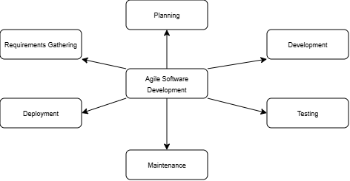

Figure 1: Agile SDLC Cycle Diagram (Planning → Requirements → Design → Dev/Test → Review/Deploy)

 | Computer Device
Processor (CPU) | Intel Core i3 / AMD Ryzen 3 (or equivalent)
Operating System | Windows 10
Memory | 4 GB
Storage | 128GB SSD / 500GB HDD
Monitor/Display | 13-inch display (1280 x 720 resolution)

Table 2: Hardware Specifications

Visual Studio Code | 1.14+
Next.js | 16.2.6+
Tailwind CSS | 4.2.2+
Laravel(PHP) | 13.4.0+
MySQL | 8.4+
PlanetScale | 0.281.0+
Vercel | 50.44.0+
Railway | 4.37.1+
Github | 3.5.7+
Postman | 11+
Figma | 126.0.0+
Table 3: Software Stable Release

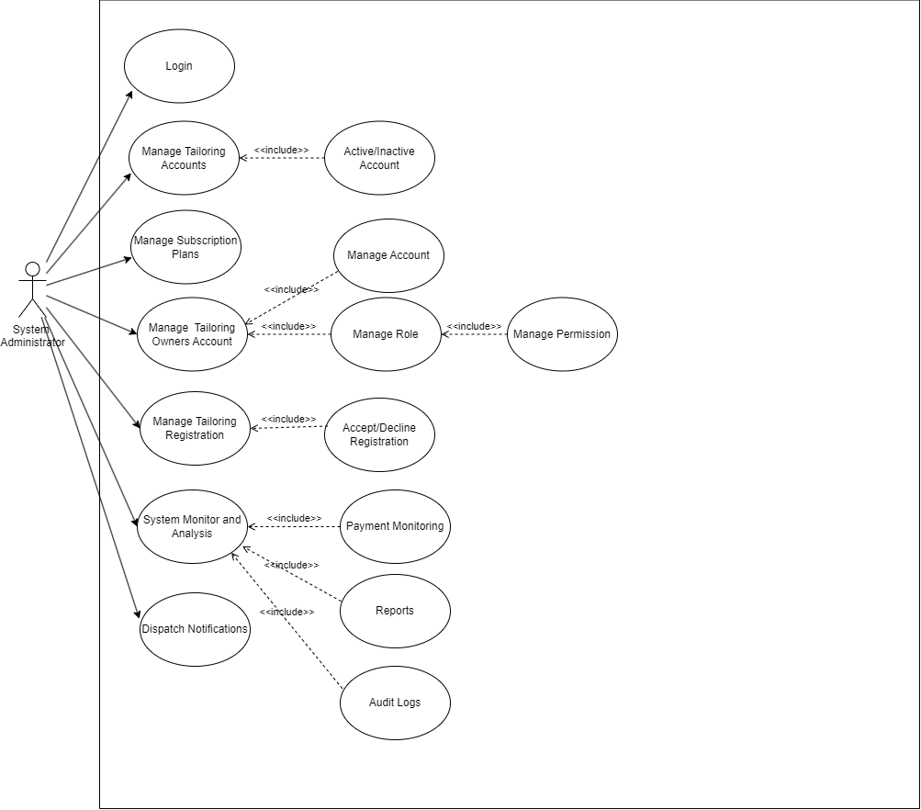
Figure 2: Administrative Module (Use Case)
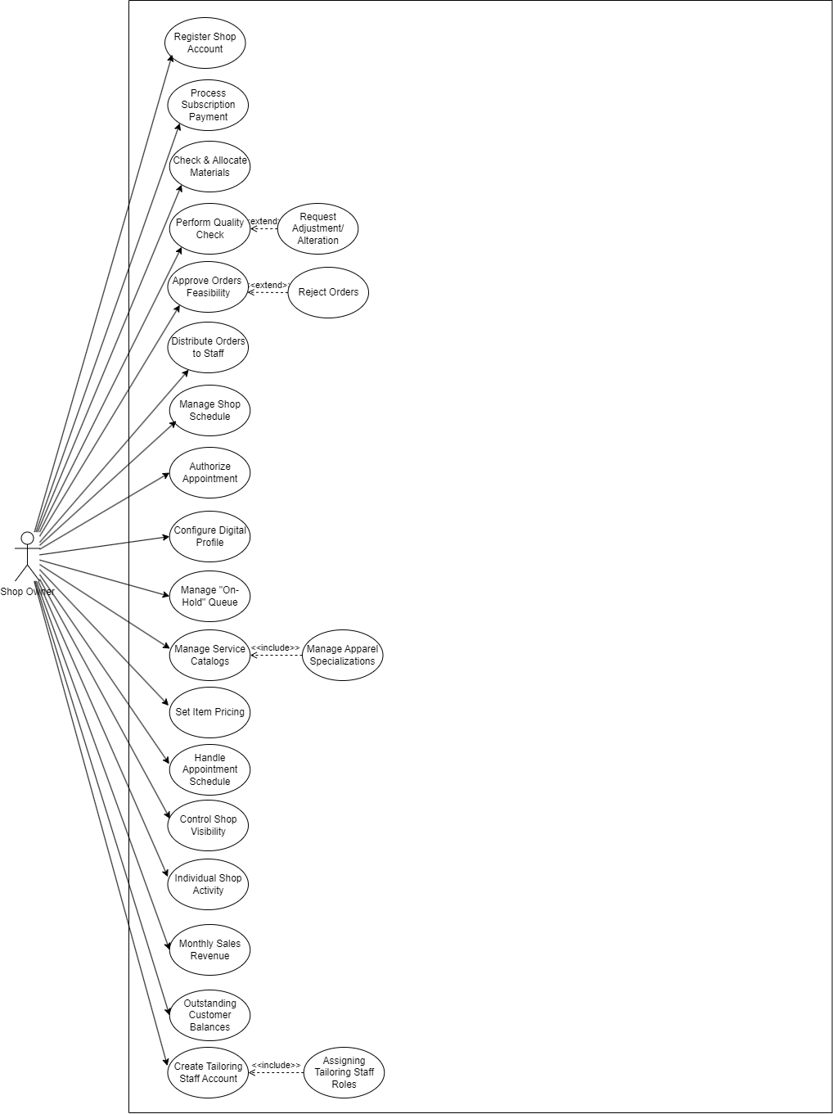
Figure 4: Shop Owner Module (Use Case)

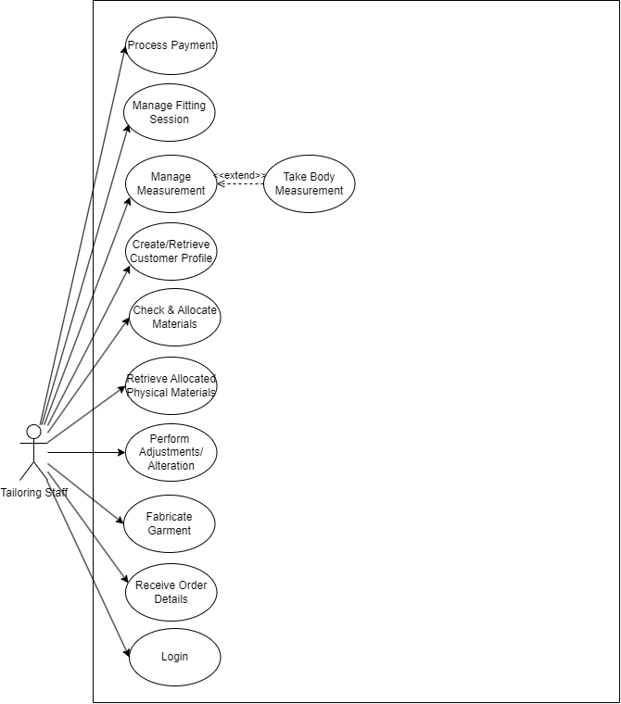
Figure 3: Tailoring Staff Module (Use Case)

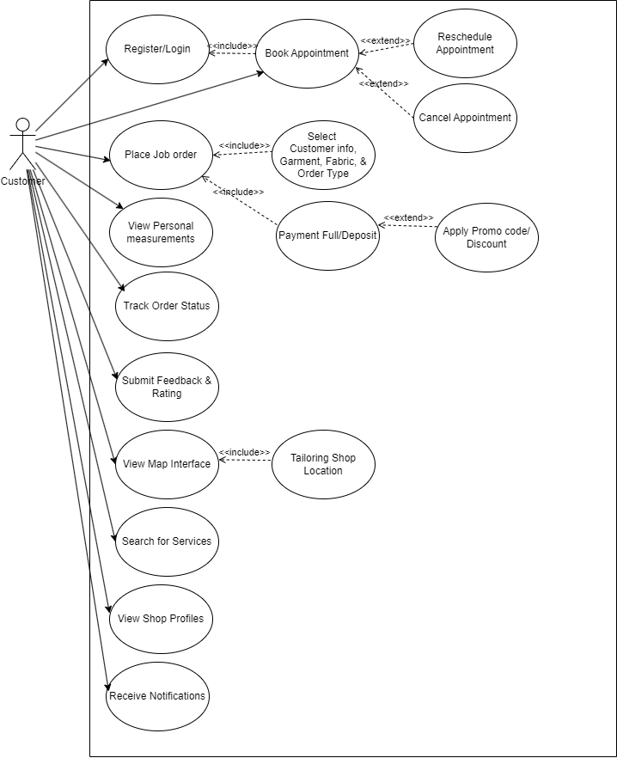
Figure 5: Customer Module (Use Case)

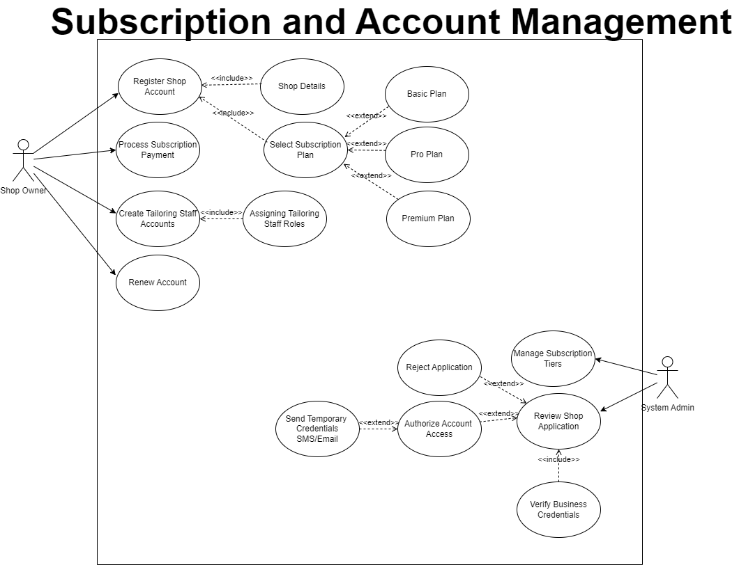
Figure 6: Subscription and Account Management (Use Case)

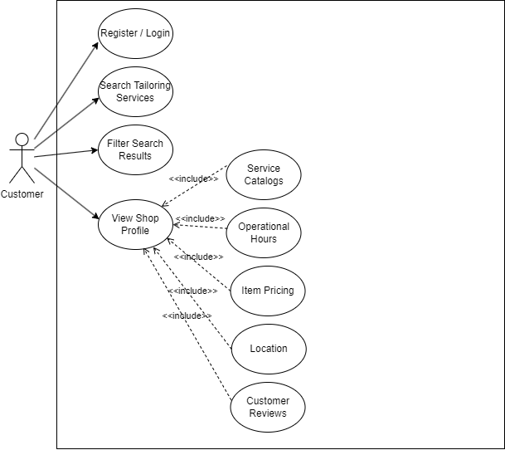
Figure 7: Shop Discovery and Search Module (Use Case)

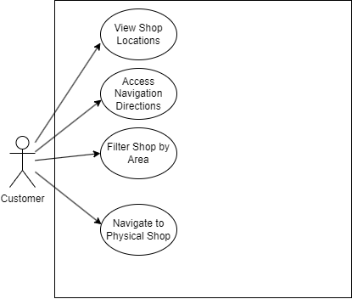
Figure 8: Map-Based Interfaced (Use Case)

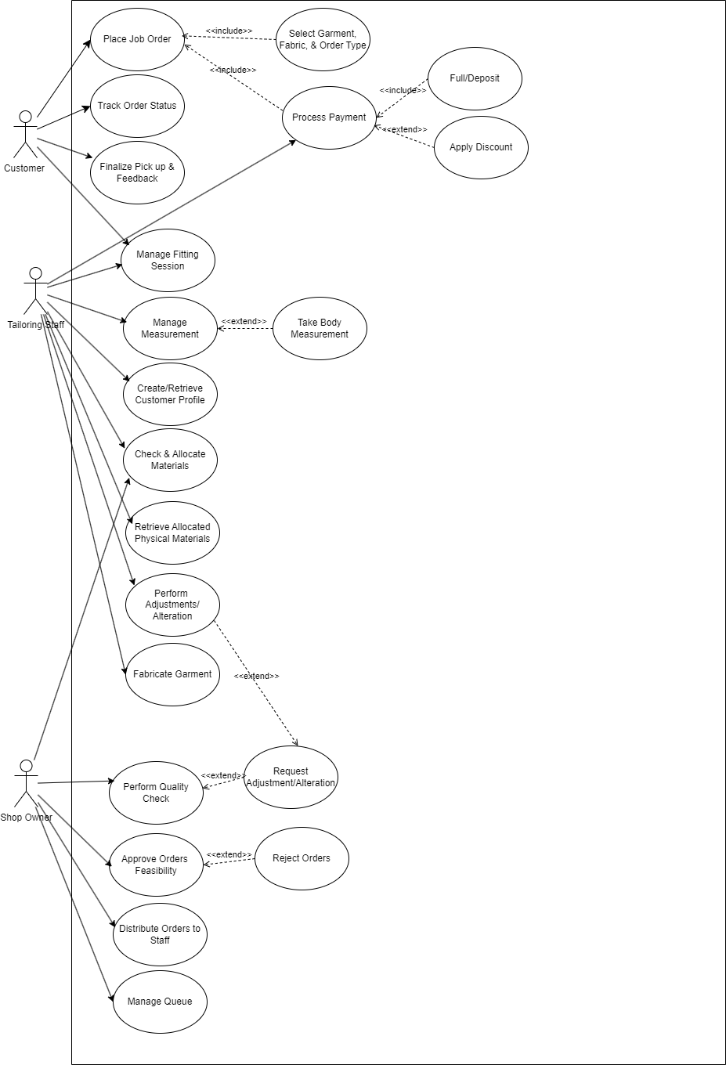
Figure 9: Order Tracking and Measurement Module (Use Case)

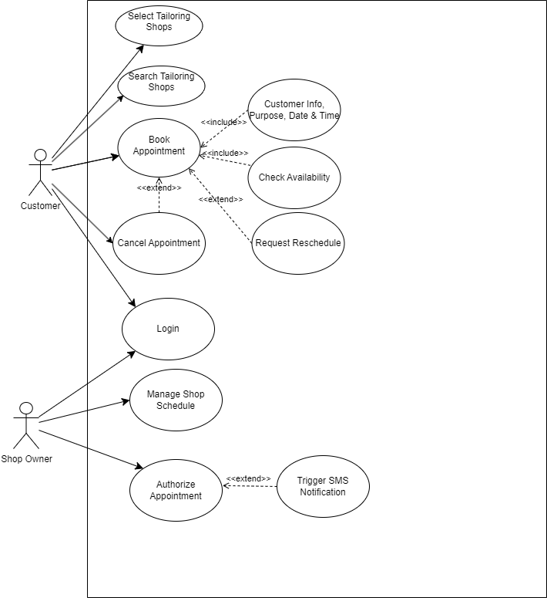
Figure 10: Appointment Module (Use Case)

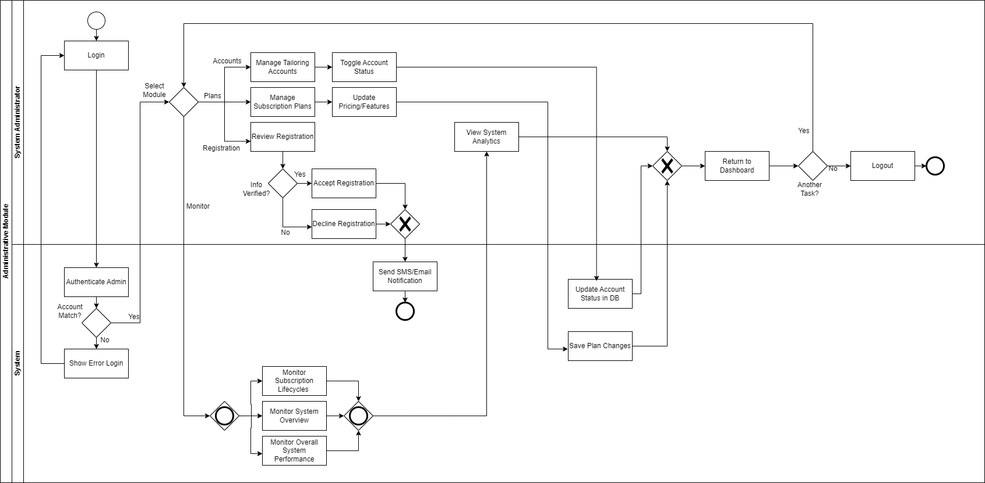
Figure 11: Administrative Module (BPMN)

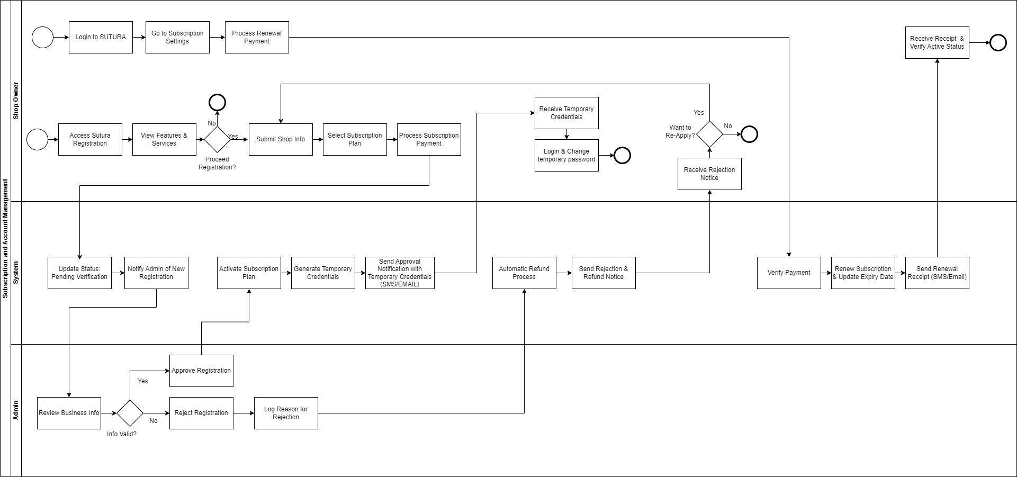
Figure 12: Subscription and Account Management (BPMN)
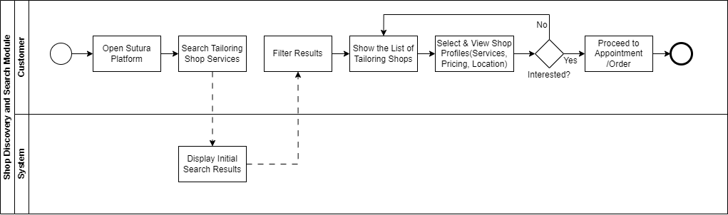
Figure 13: Shop Discovery and Search Module (BPMN)
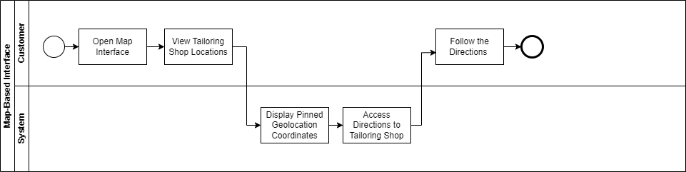
Figure 14: Map-Based Interfaced (BPMN)

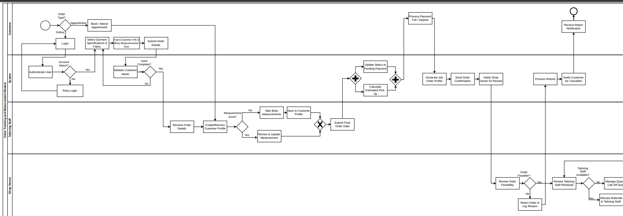
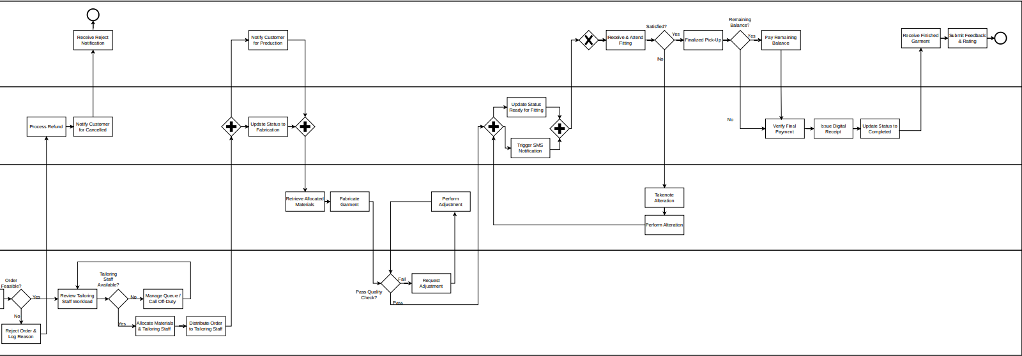
Figure 15: Order Tracking and Measurement Module (BPMN)
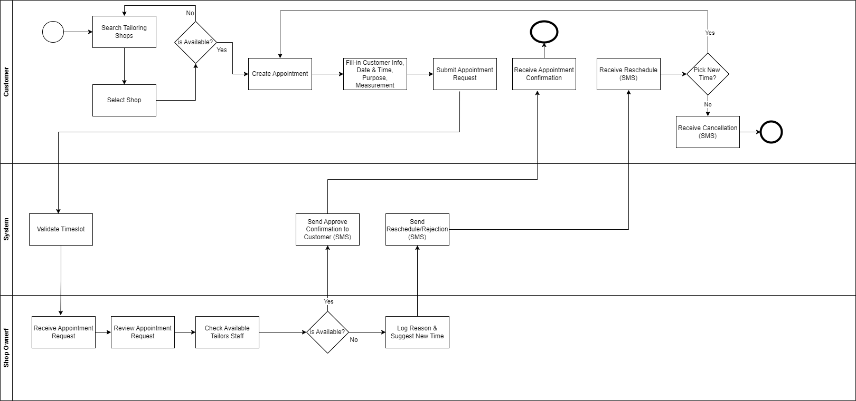
Figure 16: Appointment Module (BPMN)

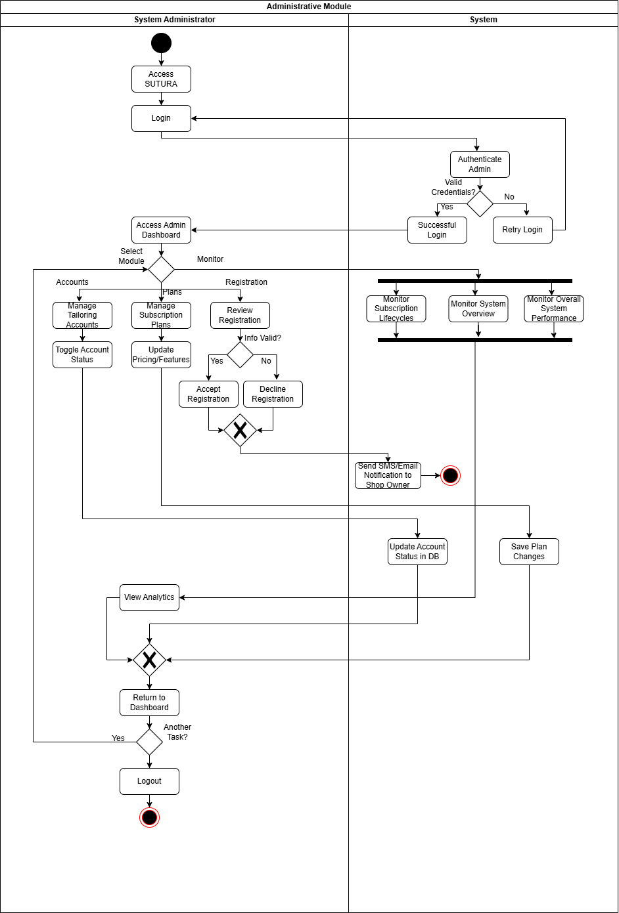
Figure 17: Administrative Module (Activity Diagram)

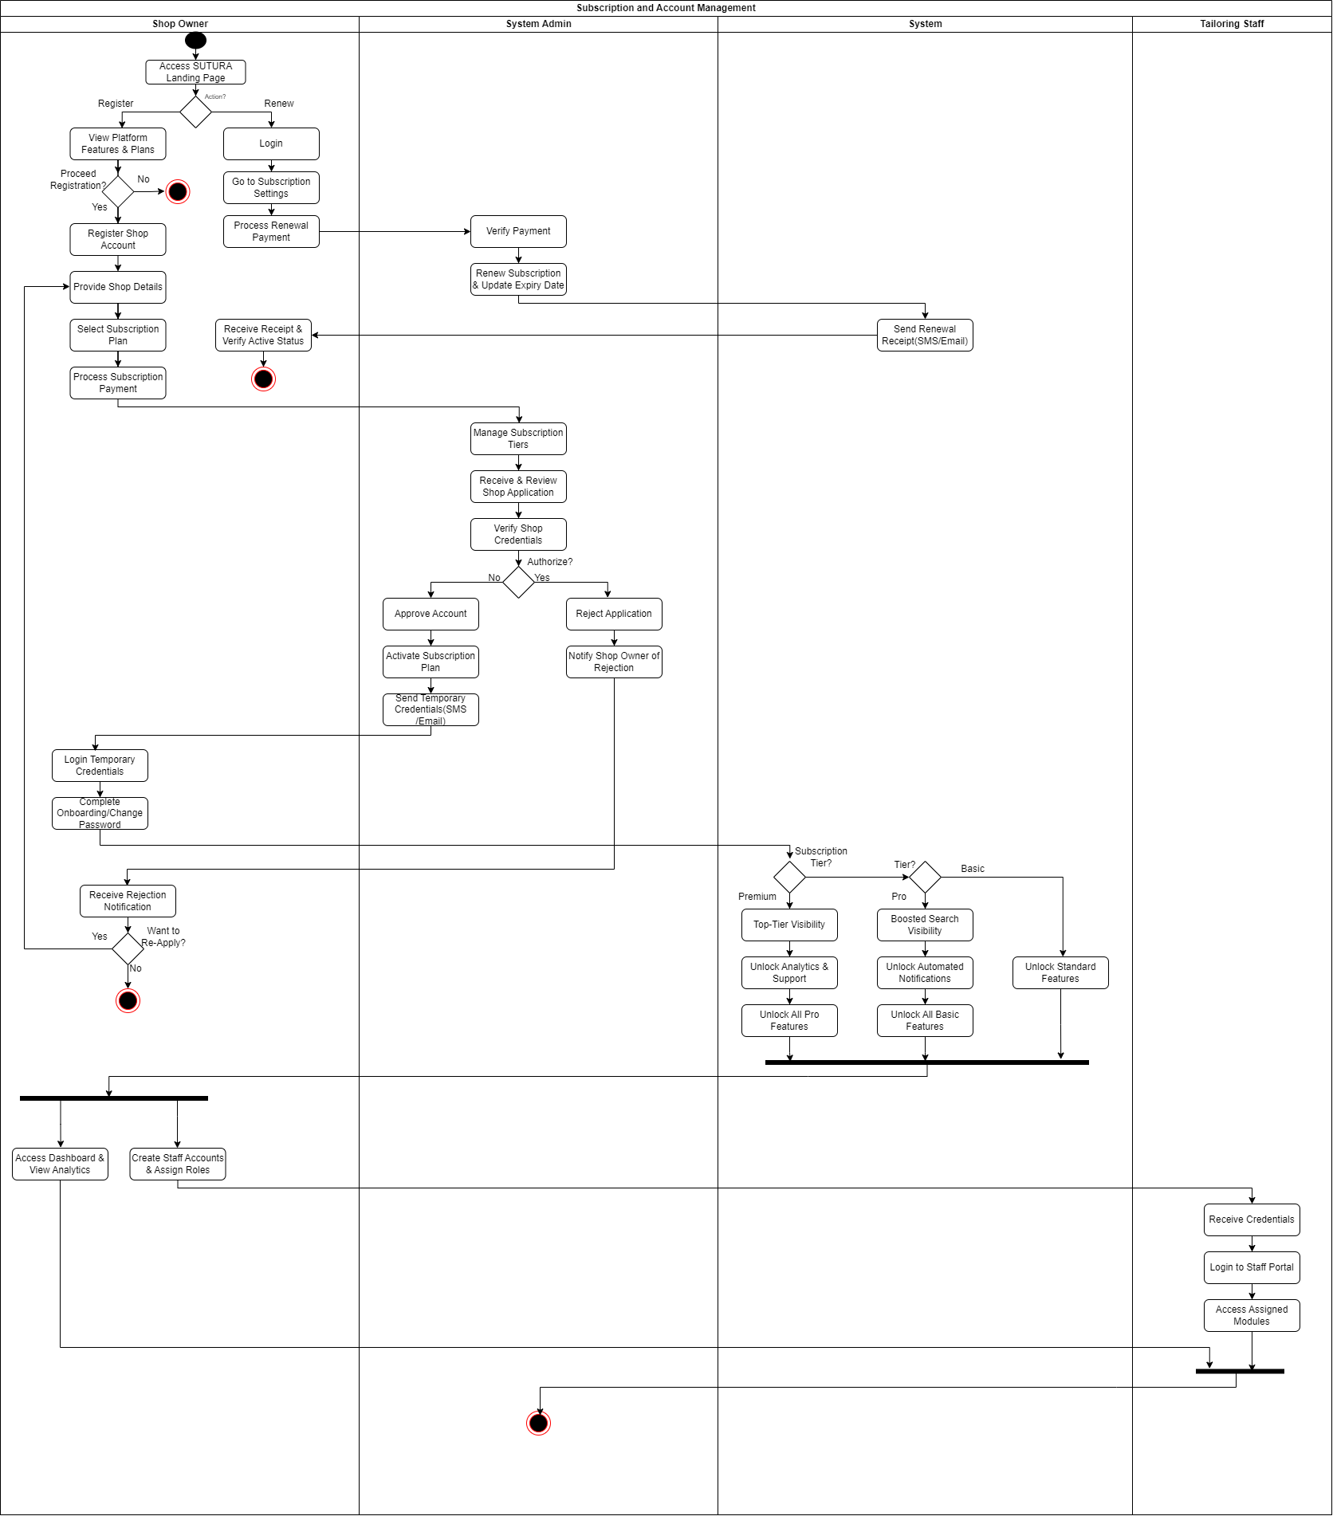
Figure 18: Subscription and Account Management (Activity Diagram)
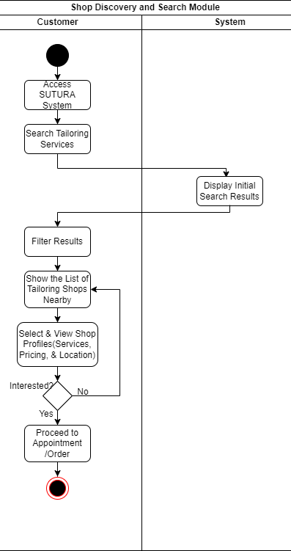
Figure 19: Shop Discovery and Search Module (Activity Diagram)

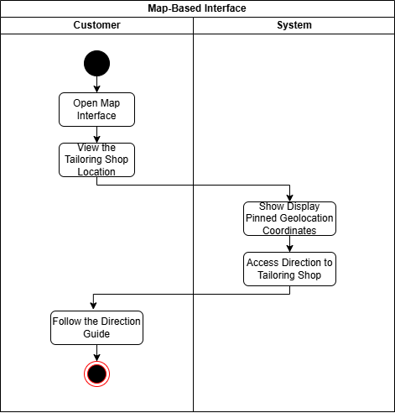
Figure 20: Map-Based Interfaced (Activity Diagram)

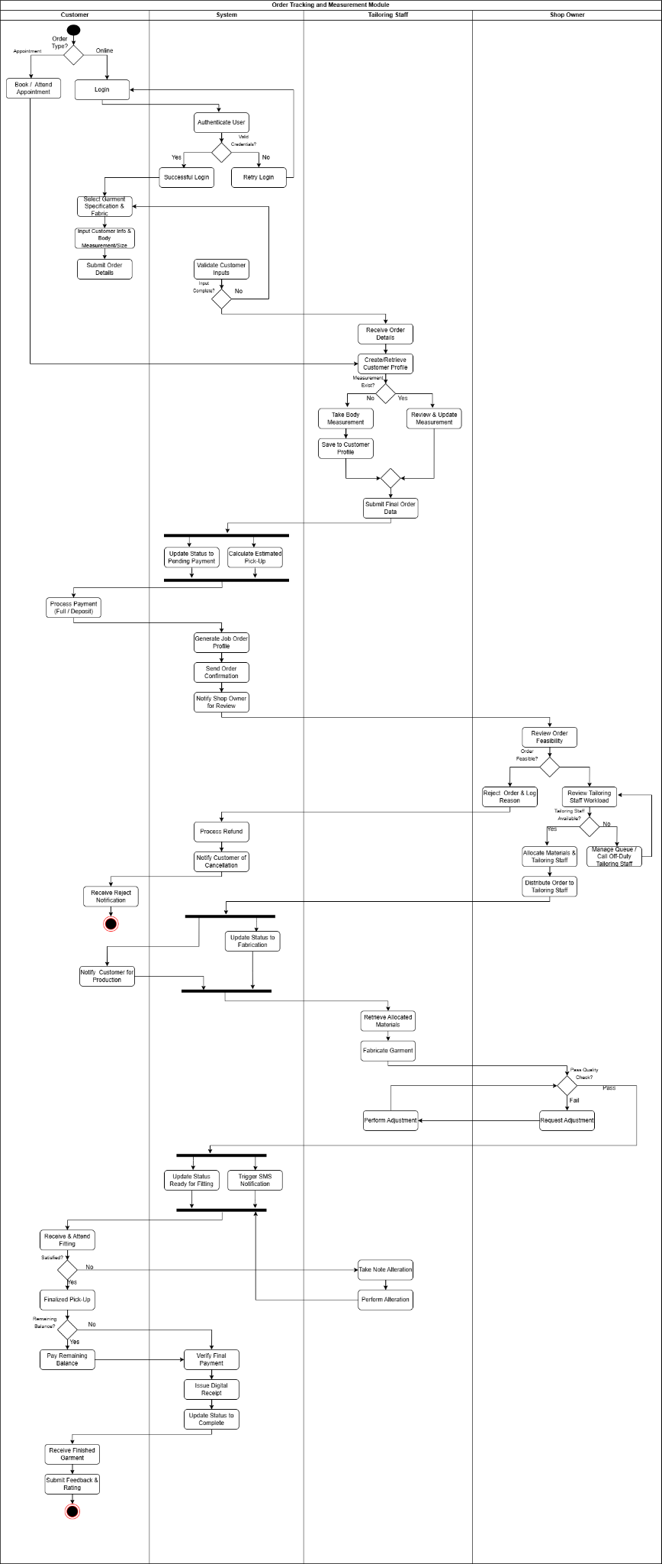

Figure 21: Order Tracking and Measurement Module (Activity Diagram)

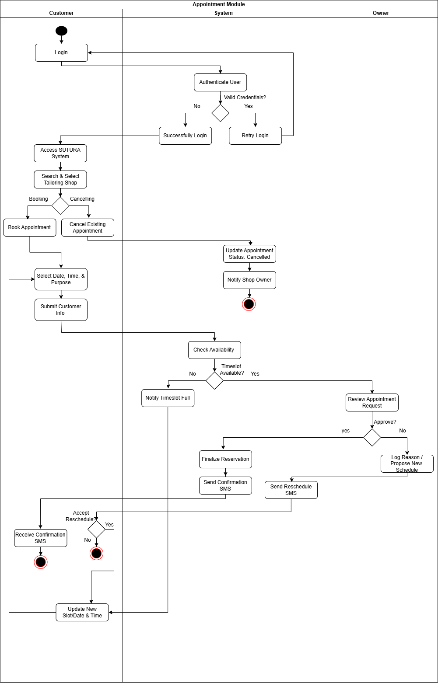
Figure 22: Appointment Module (Activity Diagram)
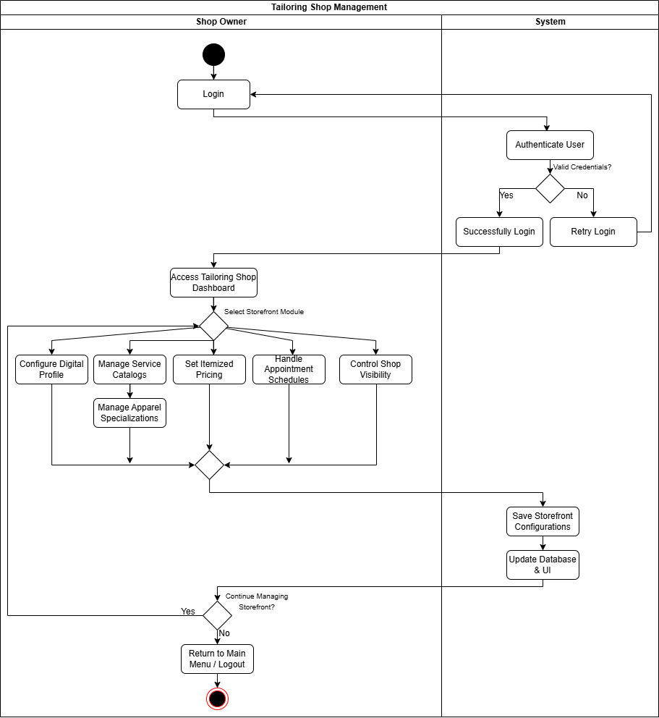
Figure 23: Tailoring Shop Management Module (Activity Diagram)

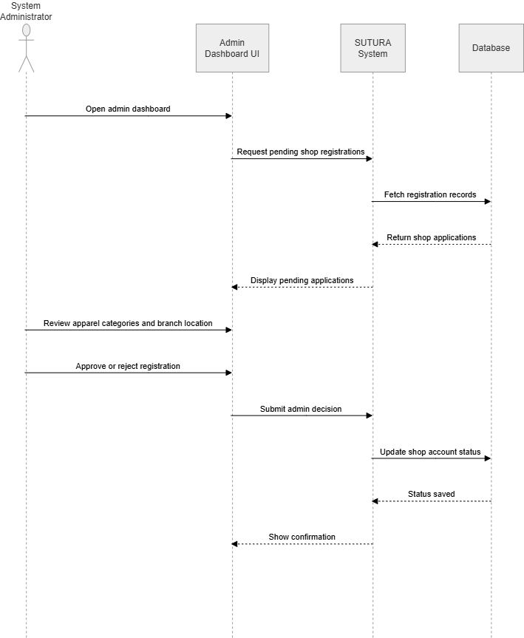
Figure 24: Administrative Dashboard (Sequence Diagram)

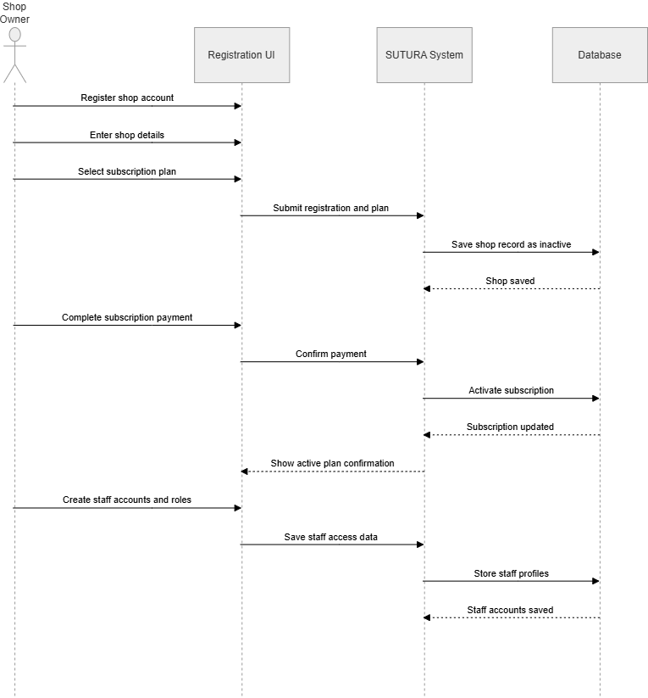
Figure 25: Subscription and Account Management (Sequence Diagram)

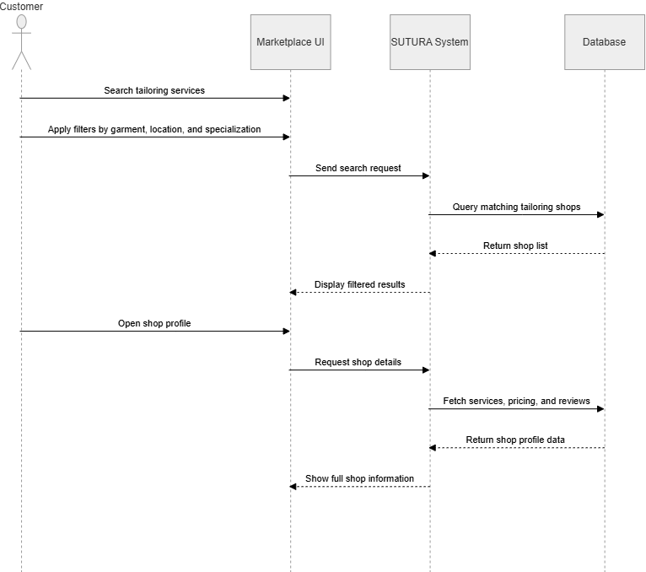
Figure 26: Shop Discovery and Search (Sequence Diagram)

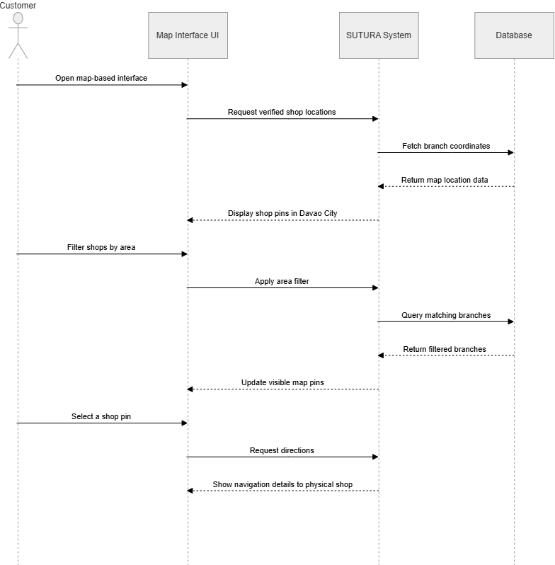
Figure 27: Map-Based Interface (Sequence Diagram)

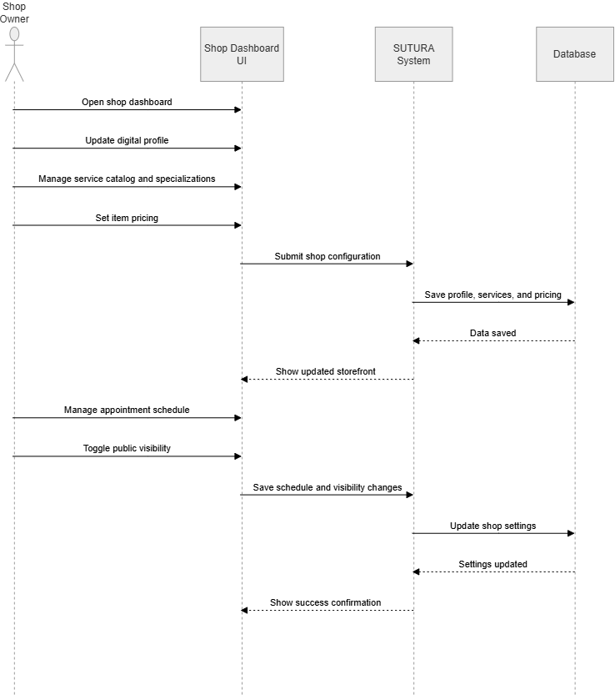
Figure 28: Tailoring Shop Dashboard (Sequence Diagram)

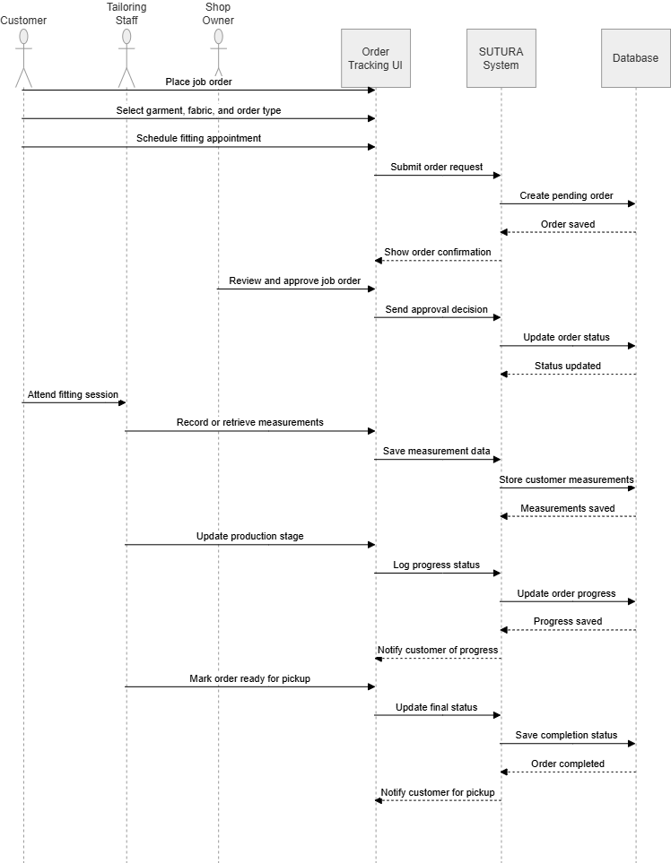
Figure 29: Order Tracking and Measurement (Sequence Diagram)

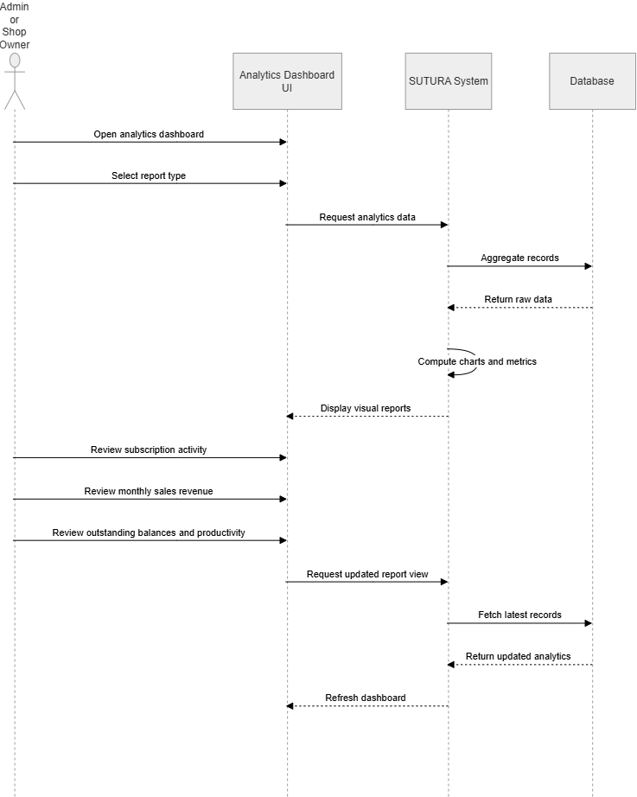
Figure 30: Interactive Analytics Dashboard (Sequence Diagram)
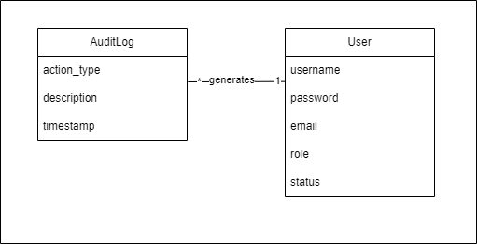
Figure 31: Administrative Module (Domain Diagram)
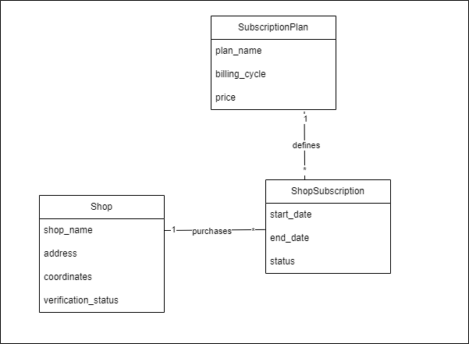
Figure 32: Subscription and Account Management (Domain Diagram)
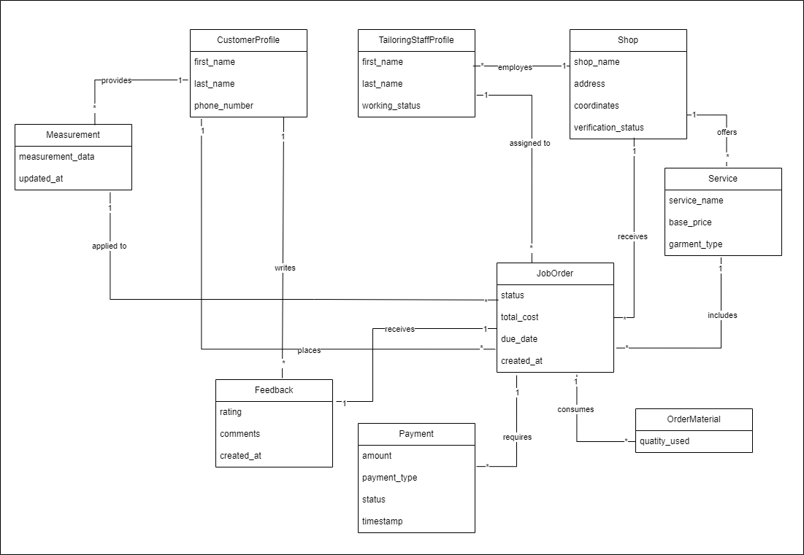
Figure 33: Order Tracking and Measurement Module (Domain Diagram)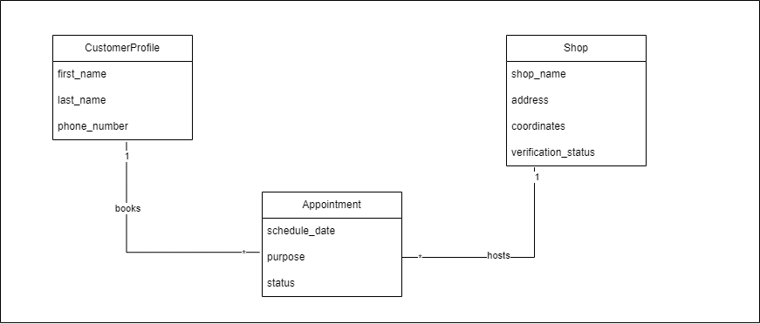
Figure 34: Appointment Module (Domain Diagram)
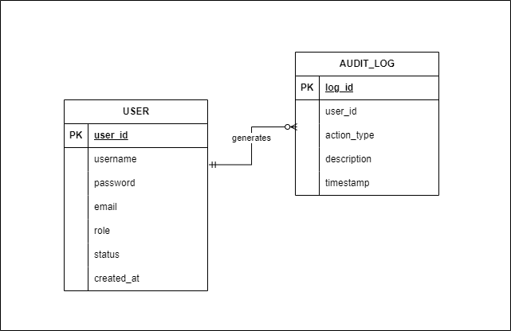
Figure 35: Administrative Module (Entity Relationship Diagram)
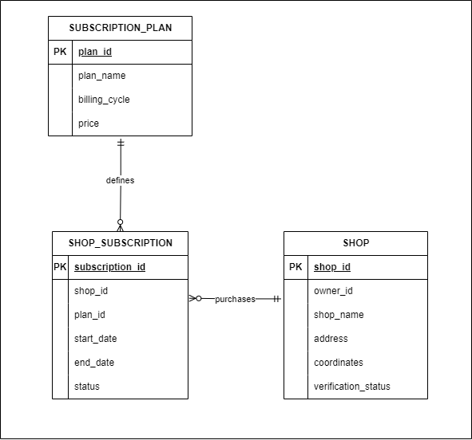
Figure 36: Subscription and Account Management (Entity Relationship Diagram)

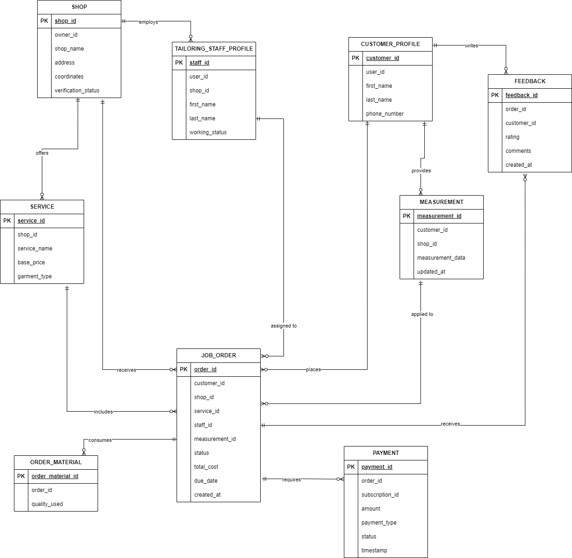
Figure 37: Order Tracking and Measurement Module (Entity Relationship Diagram)
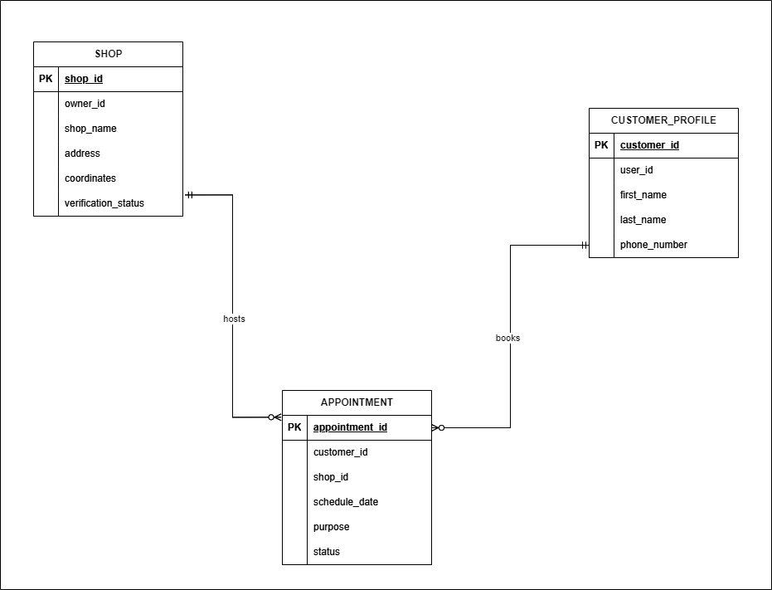
Figure 38: Appointment Module (Entity Relationship Diagram)
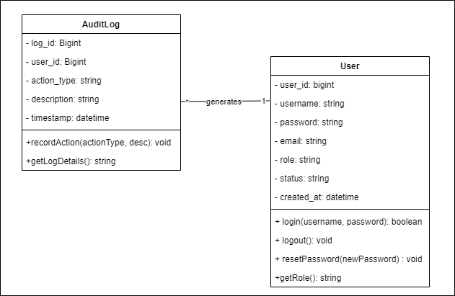
Figure 39: Administrative Module (Class Diagram)
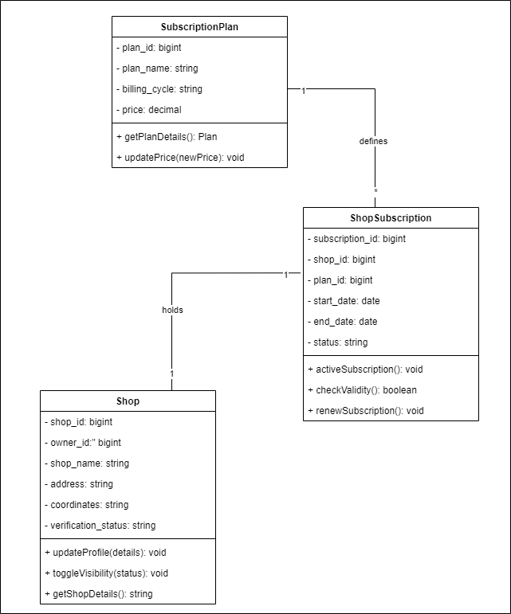
Figure 40: Subscription and Account Management (Class Diagram)
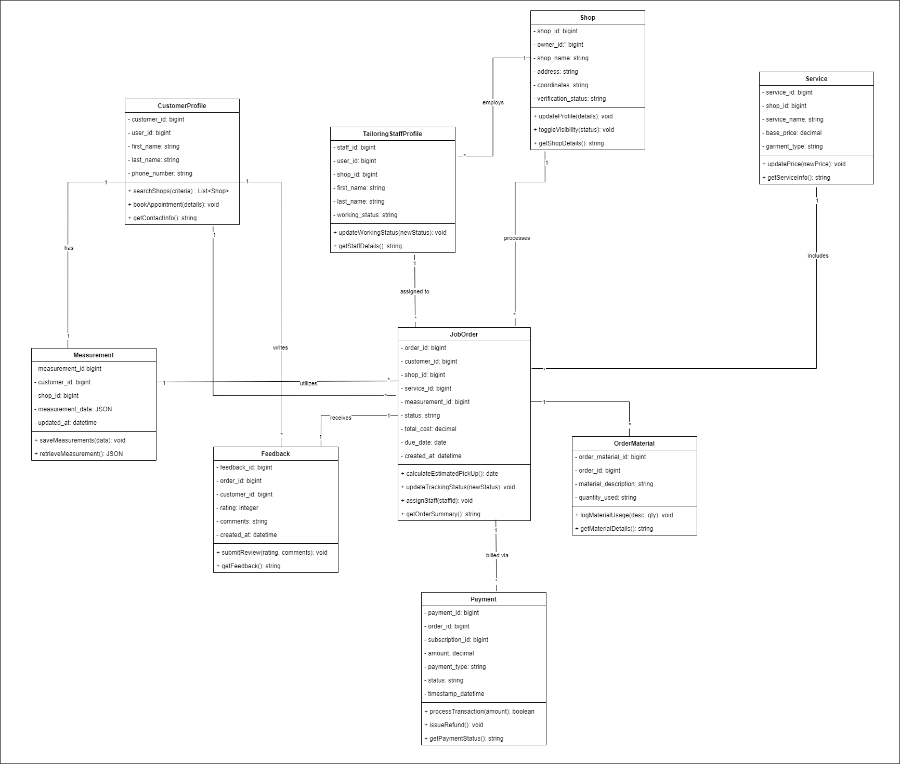
Figure 41: Order Tracking and Measurement Module (Class Diagram)
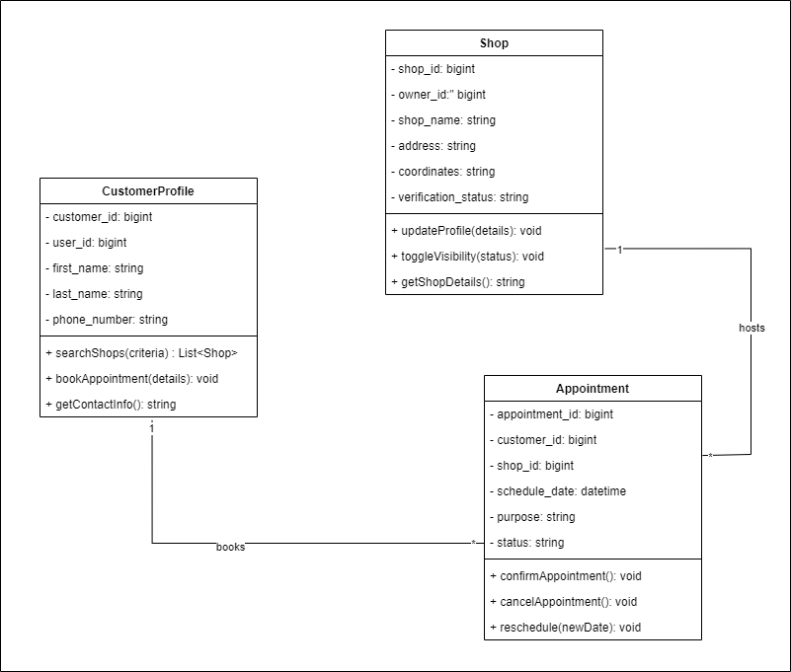
Figure 42: Appointment Module (Class Diagram)
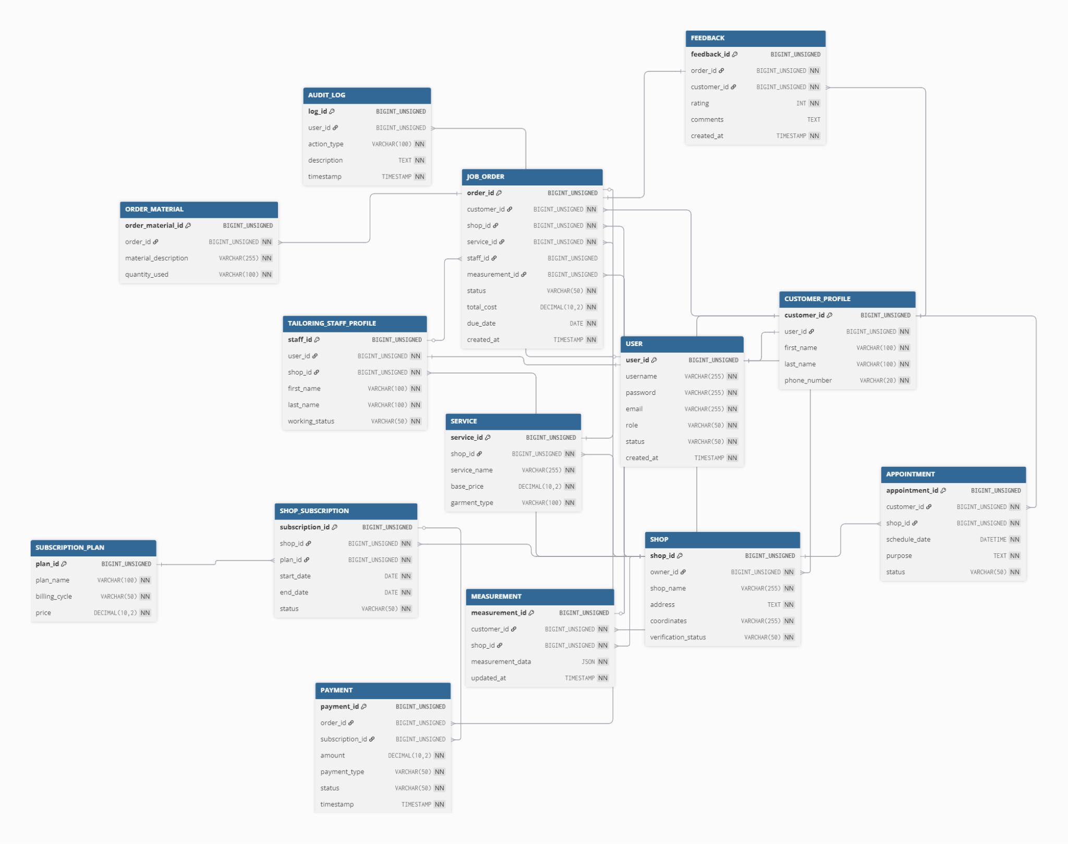
Figure 43: Database Schema

MONTH | FEBRUARY |  |  |  | MARCH |  |  |  | APRIL |  |  |  | MAY |  |  |  | JUNE
ACTIVITIES | WEEKS
 | 1 | 2 | 3 | 4 | 1 | 2 | 3 | 4 | 1 | 2 | 3 | 4 | 1 | 2 | 3 | 4 | 1 | 2 | 3 | 4
Idea Brainstorming
Abstract
Title Defense
Project Context
Letter for Interview
Project Context
Purpose and Description
Objectives
Formulation of Interview Questions
Interview
Scope and Limitations
Review of Related Studies/Systems
Technical Background
Appendix (References and Curriculum Vitae)
Figure 44: Calendar Of Activities

Data Dictionary
Key Notations
PK | Primary Key unique row identifier
FK | Foreign Key references another table
UK | Unique Key value must be unique in column
NULL | Field is optional; may be left empty
NOT NULL | Field is mandatory; must have value
DEFAULT | Column default value when not explicitly provided

1. USER
Stores core authentication and account details for all actors in the system (Owners, Staff, Customers, Admins)
Column Name | Constraint | Data Type | Nullable | Default | Description
user_id | PK | INT / UUID | NOT NULL | None | Unique identifier for each user profile.
username | UK | VARCHAR | NOT NULL | None | Unique username for logging in.
password |  | VARCHAR | NOT NULL | None | Hashed password credential.
email | UK | VARCHAR | NOT NULL | None | Unique email address.
role |  | VARCHAR / ENUM | NOT NULL | None | System role (e.g., Shop Owner, Staff, Customer).
status |  | VARCHAR / ENUM | NOT NULL | 'Active' | Account status (e.g., Active, Suspended).
created_at |  | TIMESTAMP | NOT NULL | CURRENT_TIMESTAMP | Timestamp of when the user account was created.

2. SHOP
Represents tailoring shop profiles registered on the platform.
Column Name | Constraint | Data Type | Nullable | Default | Description
shop_id | PK | INT / UUID | NOT NULL | None | Unique identifier for each shop.
owner_id | FK | INT / UUID | NOT NULL | None | References USER.user_id (The owner of the shop).
shop_name |  | VARCHAR | NOT NULL | None | Registered business name of the shop.
address |  | TEXT | NOT NULL | None | Physical address of the shop.
coordinates |  | VARCHAR / POINT | NULL | NULL | Geographic coordinates for map positioning.
verification_status |  | VARCHAR / ENUM | NOT NULL | 'Pending' | Operational approval state (e.g., Pending, Verified).

3. TAILORING STAFF PROFILE
Contains profile details specific to individual tailoring staff members tied to a shop.
Column Name | Constraint | Data Type | Nullable | Default | Description
staff_id | PK | INT / UUID | NOT NULL | None | Unique identifier for the staff member.
user_id | FK | INT / UUID | NOT NULL | None | References USER.user_id for authentication link.
shop_id | FK | INT / UUID | NOT NULL | None | References SHOP.shop_id where they are employed.
first_name |  | VARCHAR | NOT NULL | None | Staff member's given name.
last_name |  | VARCHAR | NOT NULL | None | Staff member's family name.
working_status |  | VARCHAR / ENUM | NOT NULL | 'Active' | Availability/employment status (e.g., Active, Off-duty).

4. CUSTOMER PROFILE
Maintains details specific to clients/customers.
Column Name | Constraint | Data Type | Nullable | Default | Description
customer_id | PK | INT / UUID | NOT NULL | None | Unique identifier for the customer.
user_id | FK | INT / UUID | NOT NULL | None | References USER.user_id for authentication link.
first_name |  | VARCHAR | NOT NULL | None | Customer's first name.
last_name |  | VARCHAR | NOT NULL | None | Customer's last name.
phone_number |  | VARCHAR | NULL | NULL | Direct contact number.

5. SUBSCRIPTION PLAN
Defines tiered premium options available for shops to purchase.
Column Name | Constraint | Data Type | Nullable | Default | Description
plan_id | PK | INT / UUID | NOT NULL | None | Unique identifier for the plan.
plan_name |  | VARCHAR | NOT NULL | None | Name of tier (e.g., Basic, Premium, Gold).
billing_cycle |  | VARCHAR | NOT NULL | None | Frequency of billing (e.g., Monthly, Yearly).
price |  | DECIMAL | NOT NULL | 0.00 | Cost of the subscription plan.

6. SHOP SUBSCRIPTION
Tracks subscription periods and active tiers purchased by shops.
Column Name | Constraint | Data Type | Nullable | Default | Description
subscription_id | PK | INT / UUID | NOT NULL | None | Unique identifier for the subscription record.
shop_id | FK | INT / UUID | NOT NULL | None | References SHOP.shop_id.
plan_id | FK | INT / UUID | NOT NULL | None | References SUBSCRIPTION_PLAN.plan_id.
start_date |  | DATE / TIMESTAMP | NOT NULL | None | Activation date of the subscription.
end_date |  | DATE / TIMESTAMP | NOT NULL | None | Expiration date of the subscription.
status |  | VARCHAR / ENUM | NOT NULL | None | Current standing (e.g., Active, Expired, Cancelled).

7. SERVICE
Catalog of various tailoring services offered by shops.
Column Name | Constraint | Data Type | Nullable | Default | Description
service_id | PK | INT / UUID | NOT NULL | None | Unique identifier for the service.
shop_id | FK | INT / UUID | NOT NULL | None | References SHOP.shop_id offering this service.
service_name |  | VARCHAR | NOT NULL | None | Name of service (e.g., Custom Suit Tailoring, Hemming).
base_price |  | DECIMAL | NOT NULL | None | Standard starting cost for this specific service.
garment_type |  | VARCHAR | NOT NULL | None | Categories of clothing handled (e.g., Pants, Dress, Suit).

8. APPOINTMENT
Handles physical or digital consultation bookings made by clients.
Column Name | Constraint | Data Type | Nullable | Default | Description
appointment_id | PK | INT / UUID | NOT NULL | None | Unique identifier for the reservation entry.
customer_id | FK | INT / UUID | NOT NULL | None | References CUSTOMER_PROFILE.customer_id.
shop_id | FK | INT / UUID | NOT NULL | None | References SHOP.shop_id being visited.
schedule_date |  | TIMESTAMP | NOT NULL | None | Date and time of the appointment.
purpose |  | VARCHAR / TEXT | NULL | NULL | Intent of appointment (e.g., Measurement, Fitting).
status |  | VARCHAR / ENUM | NOT NULL | 'Scheduled' | Booking state (e.g., Scheduled, Completed, Cancelled).

9. MEASUREMENT
Holds dimension datasets for a customer's fittings.
Column Name | Constraint | Data Type | Nullable | Default | Description
measurement_id | PK | INT / UUID | NOT NULL | None | Unique identifier for this measurement set.
customer_id | FK | INT / UUID | NOT NULL | None | References CUSTOMER_PROFILE.customer_id.
shop_id | FK | INT / UUID | NOT NULL | None | References SHOP.shop_id that took the measurements.
measurement_data |  | JSON / TEXT | NOT NULL | None | Structured mapping of sizing values (e.g., Chest, Waist, Inseam).
updated_at |  | TIMESTAMP | NOT NULL | CURRENT_TIMESTAMP | Last time measurements were modified.

10. JOB ORDER
The core operational table executing tailoring transactions.
Column Name | Constraint | Data Type | Nullable | Default | Description
order_id | PK | INT / UUID | NOT NULL | None | Unique identifier for the tailoring job.
customer_id | FK | INT / UUID | NOT NULL | None | References CUSTOMER_PROFILE.customer_id.
shop_id | FK | INT / UUID | NOT NULL | None | References SHOP.shop_id processing the order.
service_id | FK | INT / UUID | NOT NULL | None | References SERVICE.service_id selected.
staff_id | FK | INT / UUID | NULL | NULL | References TAILORING_STAFF_PROFILE.staff_id assigned to sew.
measurement_id | FK | INT / UUID | NOT NULL | None | References MEASUREMENT.measurement_id used.
status |  | VARCHAR / ENUM | NOT NULL | 'Pending' | Production state (e.g., Pending, Cutting, Ready, Picked Up).
total_cost |  | DECIMAL | NOT NULL | None | Final total cost calculated for the job.
due_date |  | DATE | NOT NULL | None | Expected completion/pickup deadline.
created_at |  | TIMESTAMP | NOT NULL | CURRENT_TIMESTAMP | Order placement date.

11. ORDER MATERIAL
A bridge/junction table tracking physical fabrics or raw components consumed per job order.
Column Name | Constraint | Data Type | Nullable | Default | Description
order_material_id | PK | INT / UUID | NOT NULL | None | Unique identifier for the line item.
order_id | FK | INT / UUID | NOT NULL | None | References JOB_ORDER.order_id.
quality_used |  | DECIMAL / INT | NOT NULL | None | Metric amount or count of physical material used (e.g., meters).

12. PAYMENT
Tracks financial items processed for both client work and B2B shop subscriptions.
Column Name | Constraint | Data Type | Nullable | Default | Description
payment_id | PK | INT / UUID | NOT NULL | None | Unique identifier for the payment transaction.
order_id | FK | INT / UUID | NULL | NULL | References JOB_ORDER.order_id (nullable if subscription fee).
subscription_id | FK | INT / UUID | NULL | NULL | References SHOP_SUBSCRIPTION.subscription_id (nullable if customer order).
amount |  | DECIMAL | NOT NULL | None | Amount charged and processed.
payment_type |  | VARCHAR / ENUM | NOT NULL | None | Method used (e.g., Cash, Credit Card, Digital Wallet).
status |  | VARCHAR / ENUM | NOT NULL | 'Pending' | Billing state (e.g., Pending, Completed, Refunded).
timestamp |  | TIMESTAMP | NOT NULL | CURRENT_TIMESTAMP | Exact time payment execution completed.

13. FEEDBACK
Reviews left by customers for finished orders.
Column Name | Constraint | Data Type | Nullable | Default | Description
feedback_id | PK | INT / UUID | NOT NULL | None | Unique identifier for the feedback/review.
order_id | FK | INT / UUID | NOT NULL | None | References JOB_ORDER.order_id.
customer_id | FK | INT / UUID | NOT NULL | None | References CUSTOMER_PROFILE.customer_id.
rating |  | INT | NOT NULL | None | Score rating (e.g., 1 to 5 stars).
comments |  | TEXT | NULL | NULL | Detailed notes provided by the reviewer.
created_at |  | TIMESTAMP | NOT NULL | CURRENT_TIMESTAMP | Time review was submitted.

14. AUDIT LOG
Security or activity tracking ledger recording backend actions performed by users.
Column Name | Constraint | Data Type | Nullable | Default | Description
log_id | PK | INT / UUID | NOT NULL | None | Unique tracking ID for the log event.
user_id | FK | INT / UUID | NOT NULL | None | References USER.user_id (who performed the action).
action_type |  | VARCHAR | NOT NULL | None | Nature of modification (e.g., CREATE_ORDER, UPDATE_PROFILE).
description |  | TEXT | NOT NULL | None | Summary or context string of the transaction event.
timestamp |  | TIMESTAMP | NOT NULL | CURRENT_TIMESTAMP | Precise timing metadata.

SUTURA Storyboard

PART 1 - ENTRY & ACCESS
Panel | Visual Description | User Action and System Response
1. SUTURA Landing Page | Premium landing page with SUTURA branding, short introduction, subscription teaser, and entry options: Browse as Guest, Login as Customer, Login as Shop Owner, and Login as Admin. | User selects how to enter the platform. The system routes the user either to the marketplace preview or the correct login page.
2. Login and Authentication | Login page with separate role access for Customer, Shop Owner, and System Admin. | User enters credentials. The system validates the account and redirects the user to the correct portal dashboard.

PART 2 — CUSTOMER MODULE
Panel | Visual Description | User Action and System Response
3. Marketplace Discovery | Marketplace interface with search bar, garment filters, tailoring shop cards, ratings, specialization tags, and Davao City map integration. | Customer searches garment types, filters tailoring shops by location and specialization, and browses tailoring shop results. The system displays matching tailoring shops dynamically.
4. Shop Profile and Consultation | Tailoring shop profile page containing services, gallery, pricing, ratings, branches, and consultation options. | Customer views tailoring shop details, requests consultation, books appointments, or saves the tailoring shop. The system stores the inquiry and appointment request.
5. Map-Based Interface | Interactive Davao City map containing red customer location pin and black tailoring shop pins. | Customers explore tailoring shops by area and open directions or branch information. The system updates visible shop pins based on selected filters.
6. Customer Orders and Measurements | Customer dashboard showing active tailoring orders, progress tracker, saved measurements, notifications, and saved tailoring shops. | Customers track garment progress, views measurement history, and checks order notifications. The system updates tailoring order progress and customer measurement records.
PART 3 - SHOP OWNER MODULE
Panel | Visual Description | User Action and System Response
7.Shop Owner Dashboard | Tailoring operations dashboard with KPI cards, order queue, appointments, measurements, service gallery, branch management, and sales reports. | Shop owner manages tailoring services, updates pricing, schedules appointments, records measurements, and monitors tailoring shop performance. The system updates operational shop data and customer transactions.
8.My Measurements Management | Advanced measurement management page containing customer profiles, reusable body measurements, garment sizing versions, fitting history, and tailoring preferences. | Shop owner or tailoring staff adds, edits, deletes, and updates customer measurement records and fitting information. The system stores reusable tailoring measurements and garment versions.

PART 4 - SYSTEM ADMIN MODULE
Panel | Visual Description | User Action and System Response
9. Administrative Dashboard | Administrative command center with tailoring shop approvals, subscription monitoring, account management, reports, and platform activity overview. | System administrator reviews tailoring shop registrations, validates apparel categories and branch locations, manages subscriptions, and oversees platform-wide activity. The system updates approval and subscription records.
PART 5 - ANALYTICS & REPORTING MODULE
Panel | Visual Description | User Action and System Response
10. Analytics and Reports | Interactive analytics dashboard with KPI summaries, subscription activity, monthly sales revenue, outstanding balances, and tailoring shop productivity charts. | Shop owners and system administrators review reports and analytics. The system generates real-time business insights and visual performance reports for decision-making.

PROTOTYPE
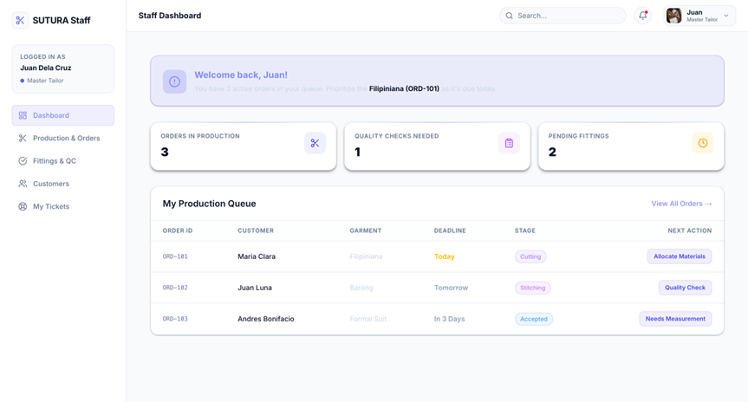
Tailoring Staff Dashboard
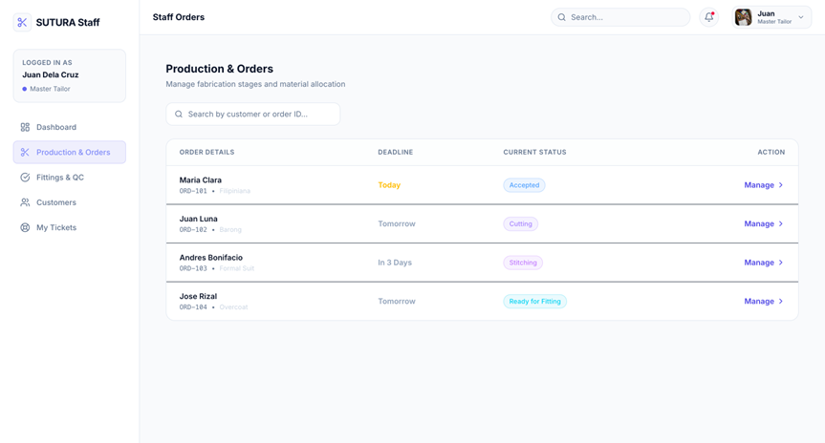
Staff Production & Orders
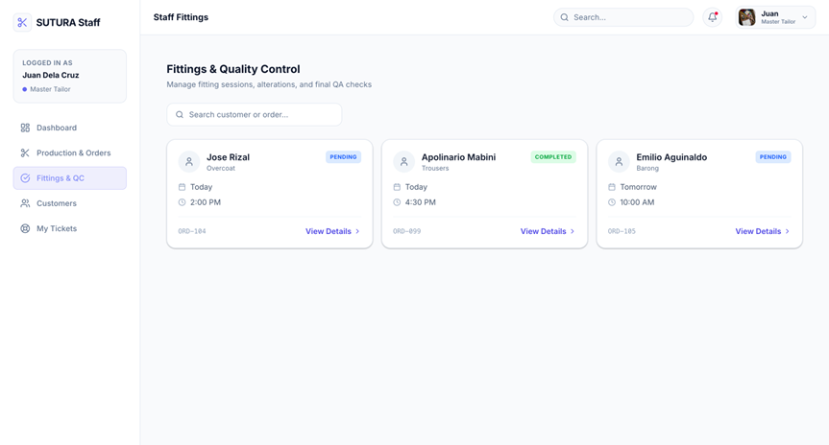
Staff Fittings & Quality Control

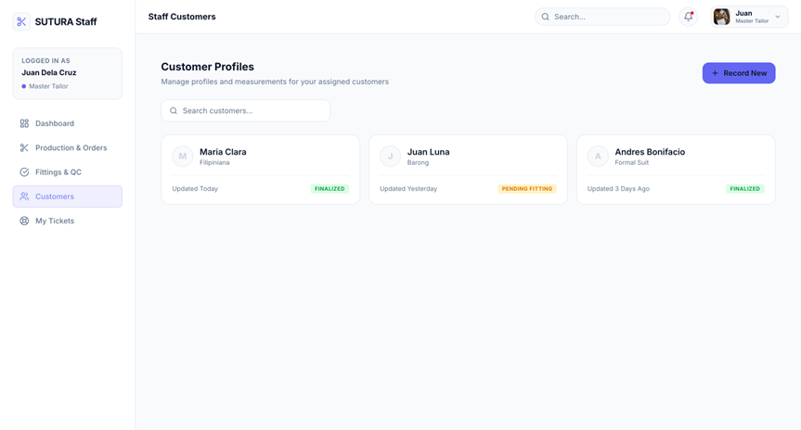
Staff Customer Profiles
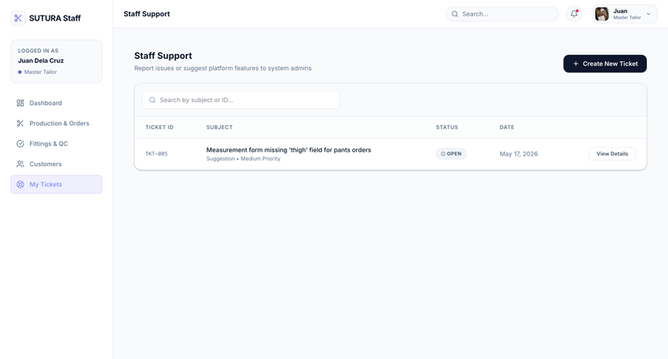
Staff Support
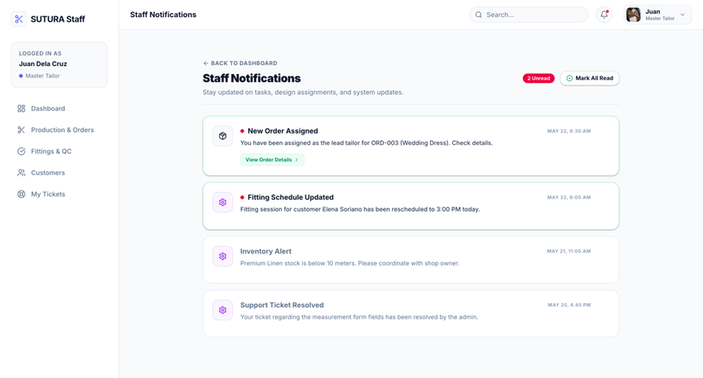
Staff Notifications
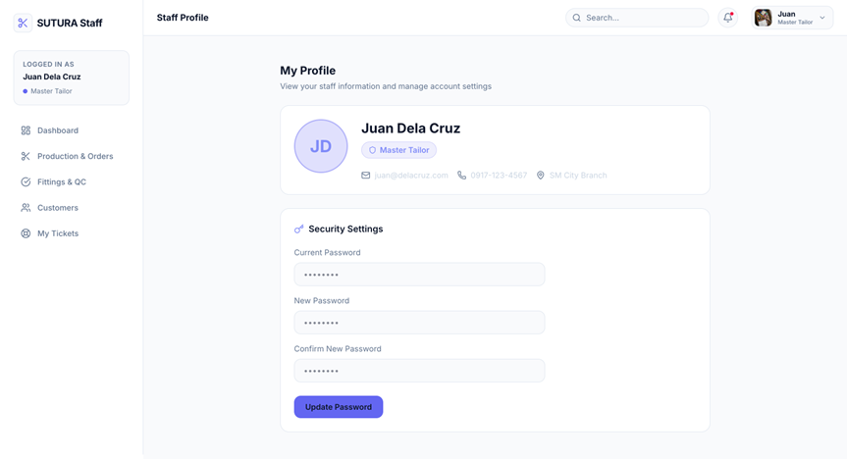
Staff Profile
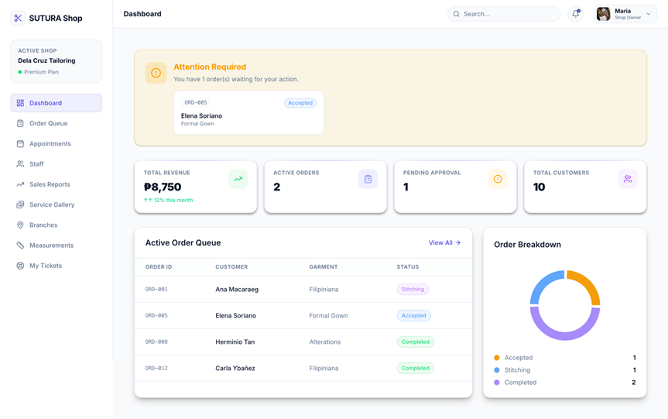
SHOP OWNER DASHBOARD

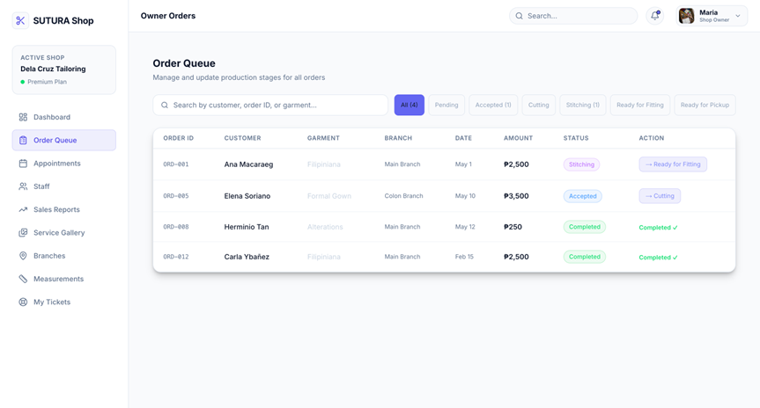
Shop Owner Order Orders

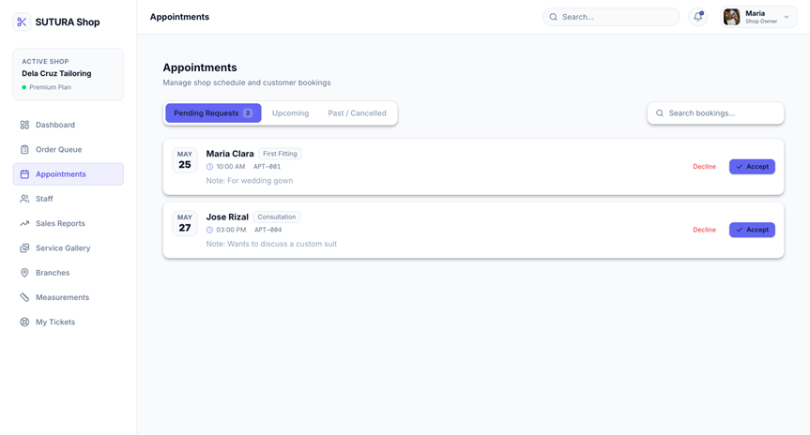
Shop Owner Appointments

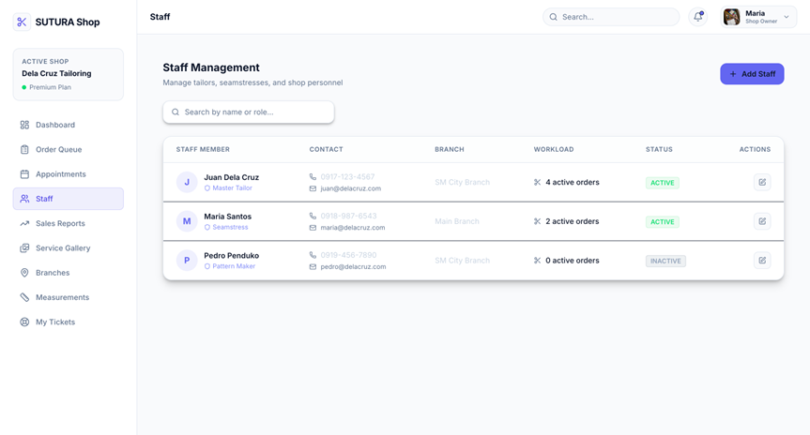
Shop Owner Staff Management
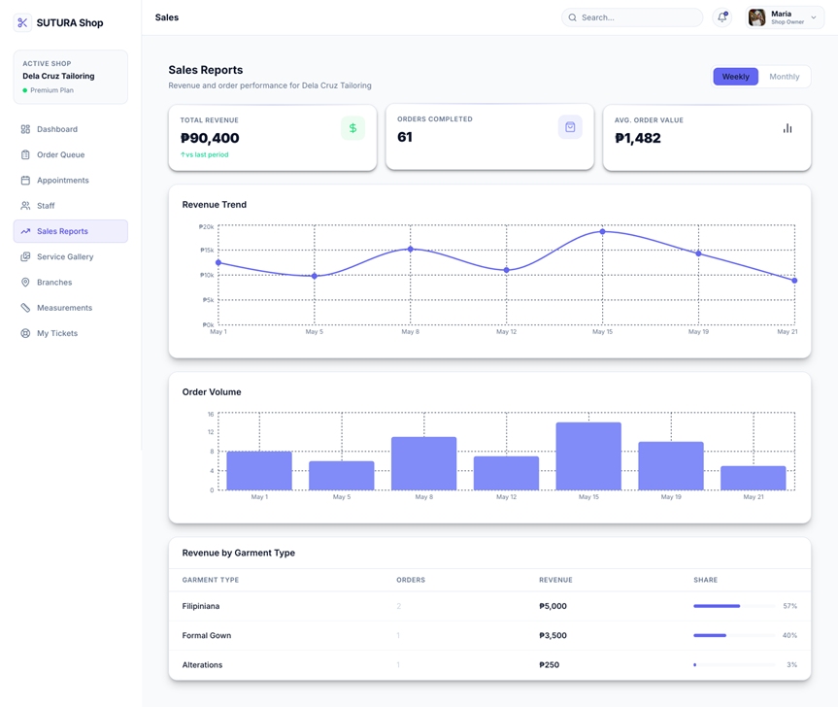
Shop Owner Sales Report
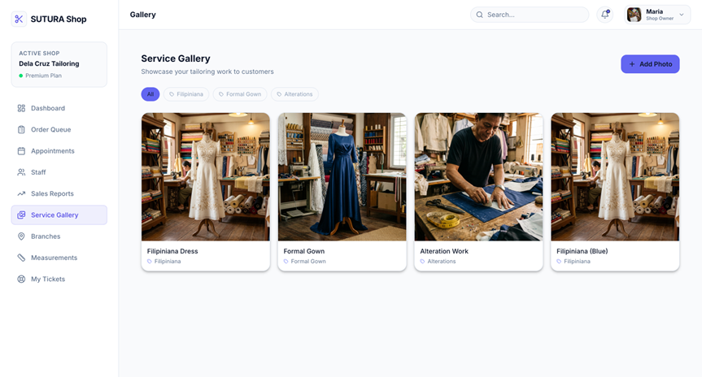
Shop Owner Service Gallery

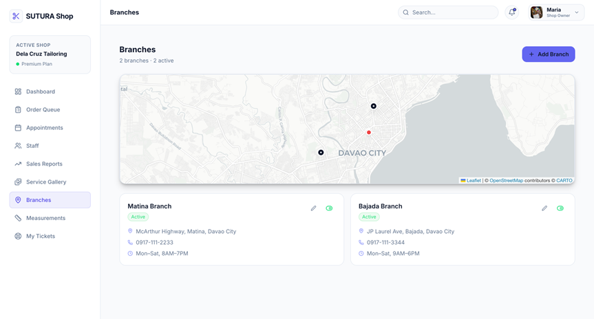
Shop Owner Branches
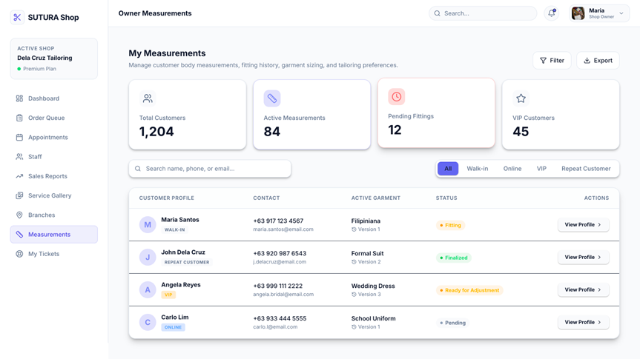
Shop Owner Measurements

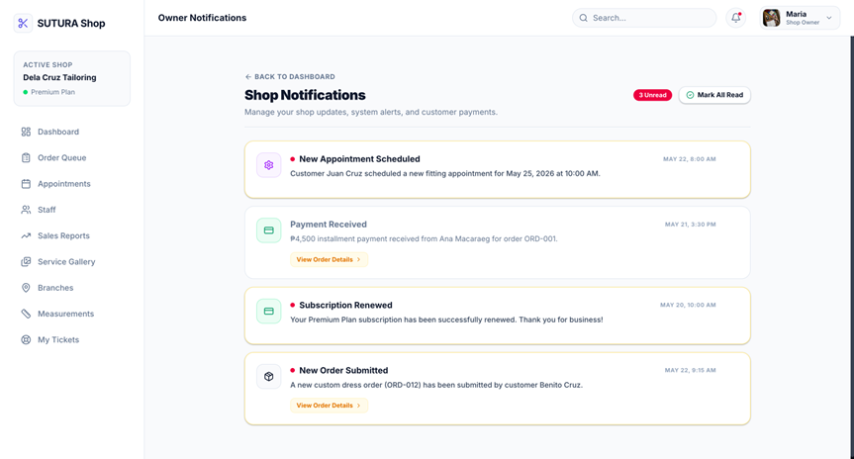
Shop Owner Notifications

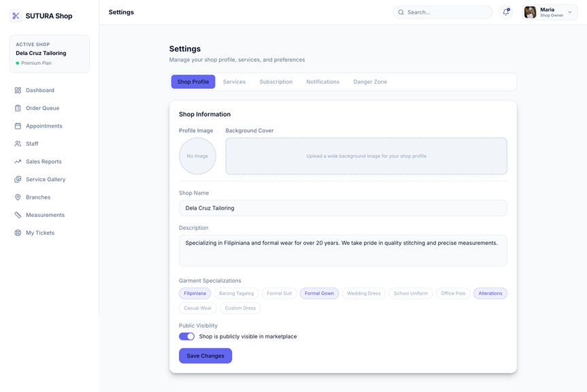
Shop Owner Settings

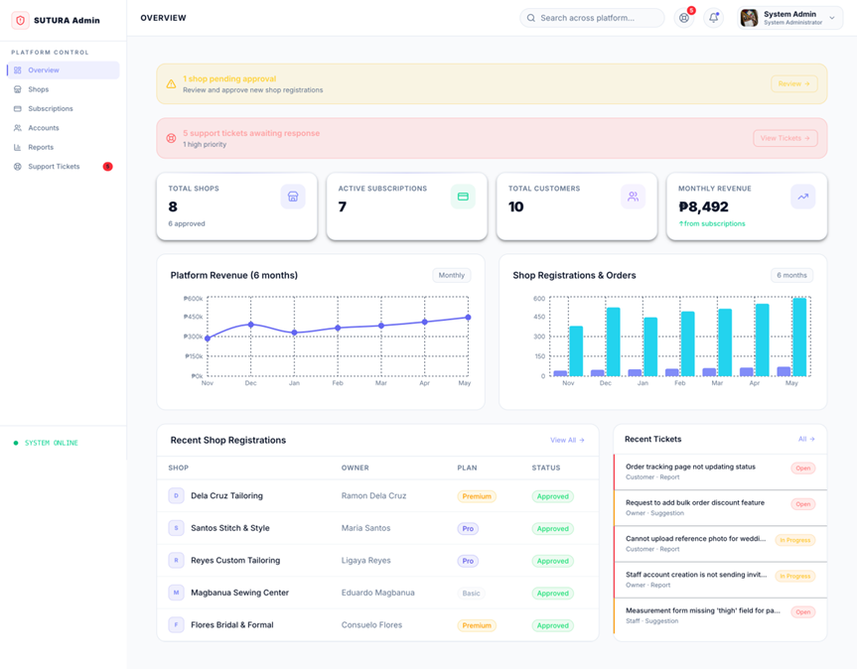
ADMIN DASHBOARD

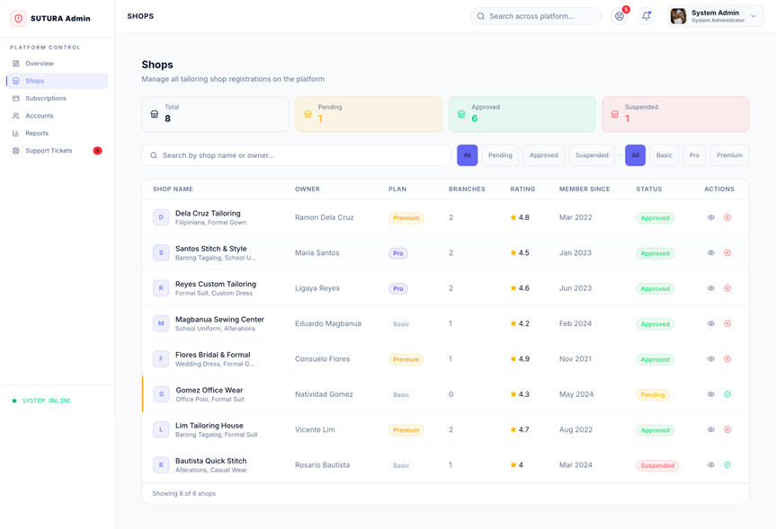
Admin Shops
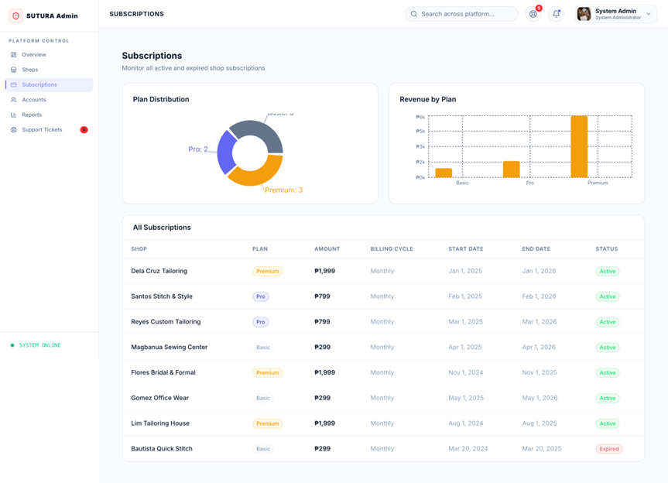
Subscription
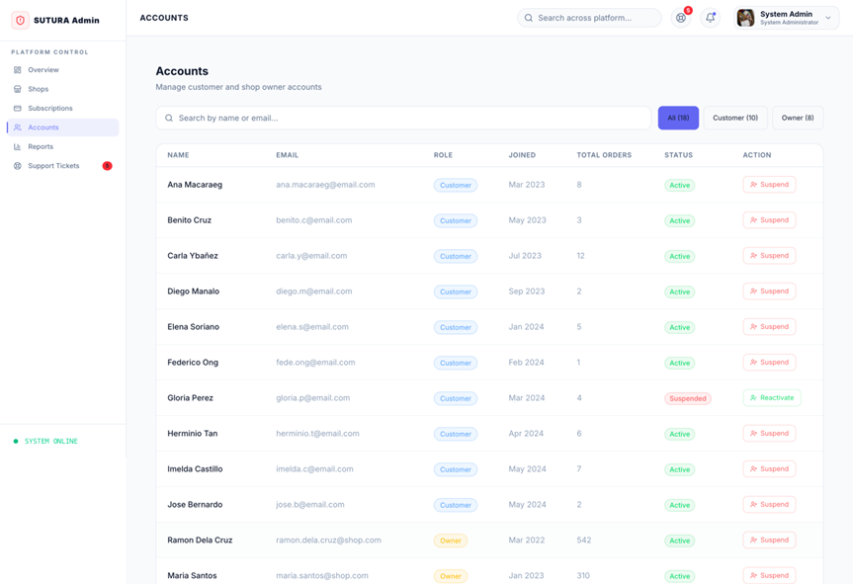
Accounts

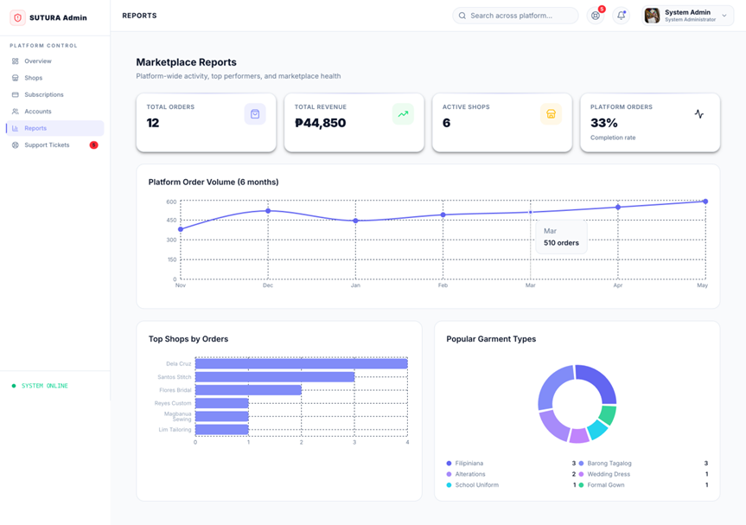
Reports

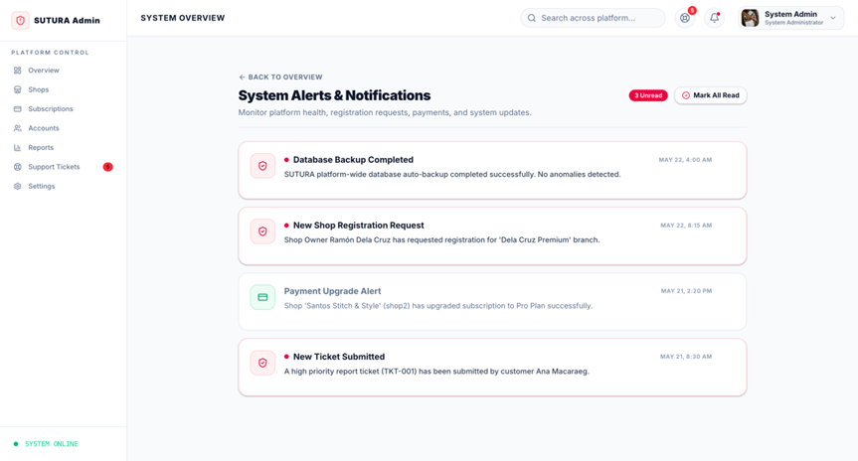
System Overview
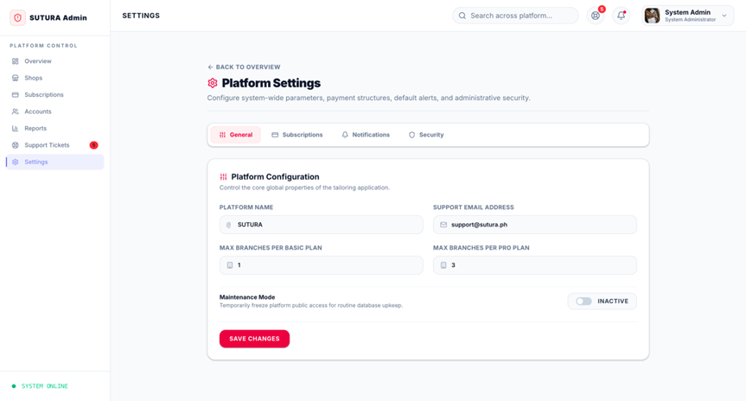
Settings

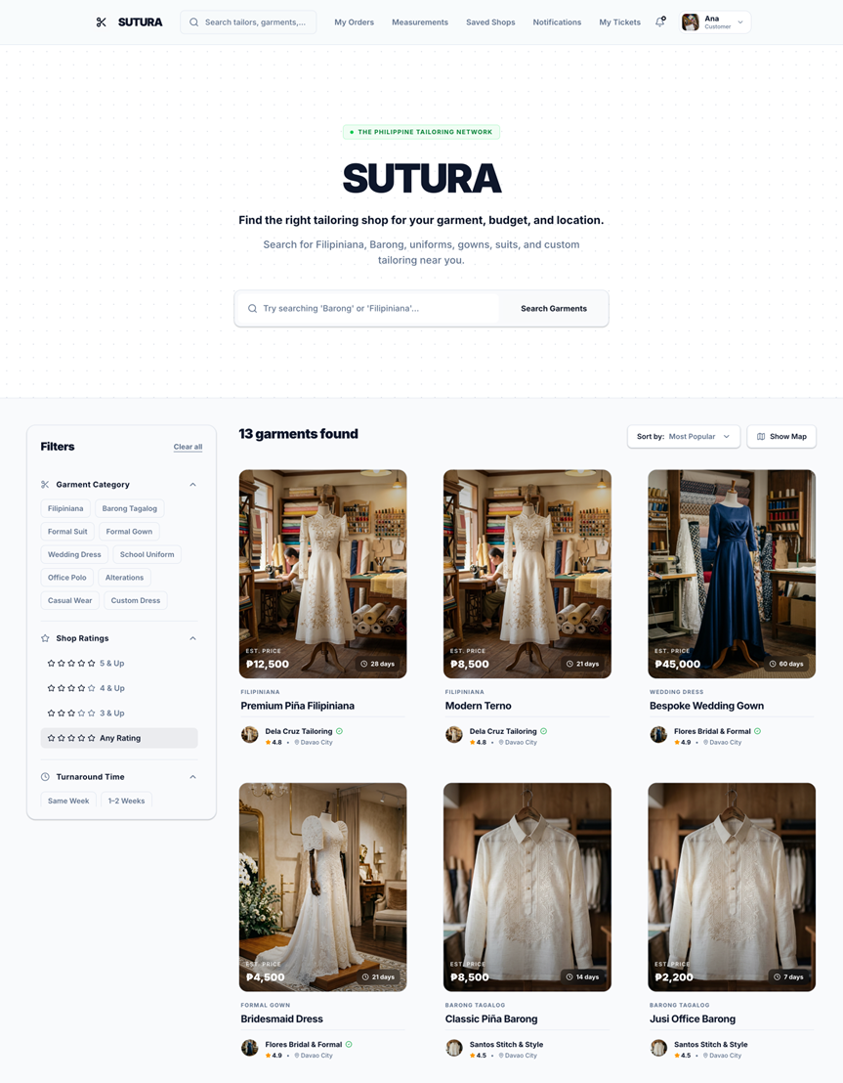
Customer Dashboard
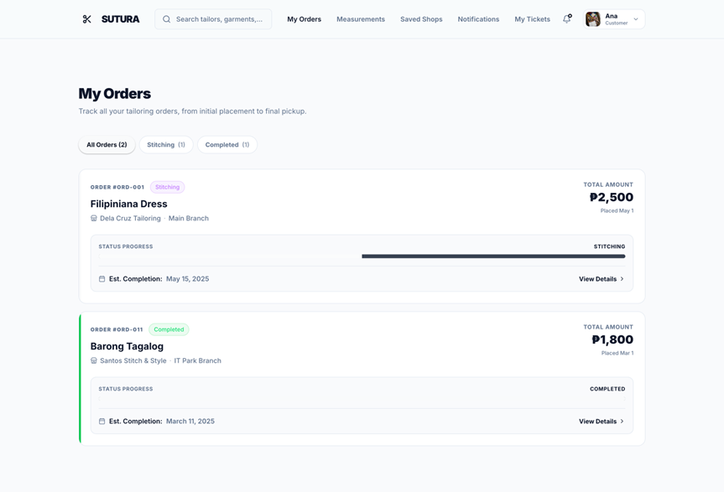
Customer Orders
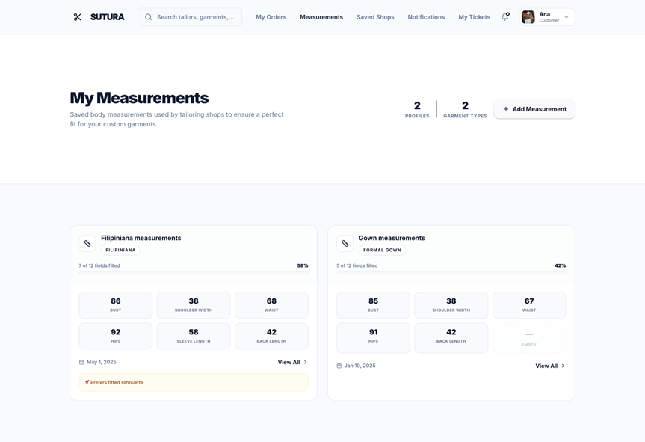
Customer Measurements
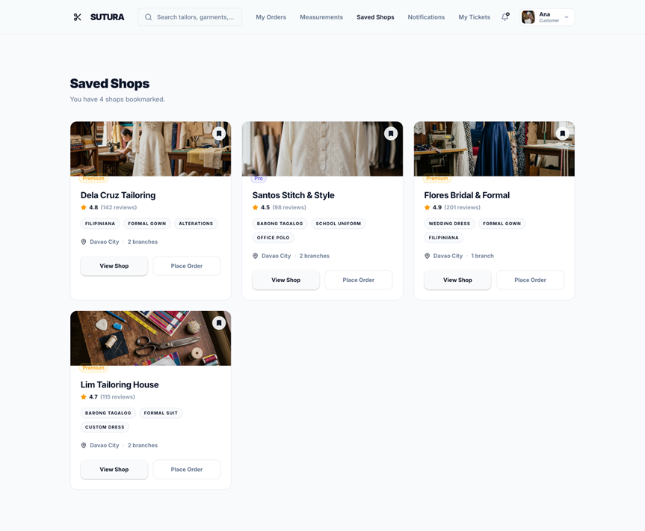
Saved Shops
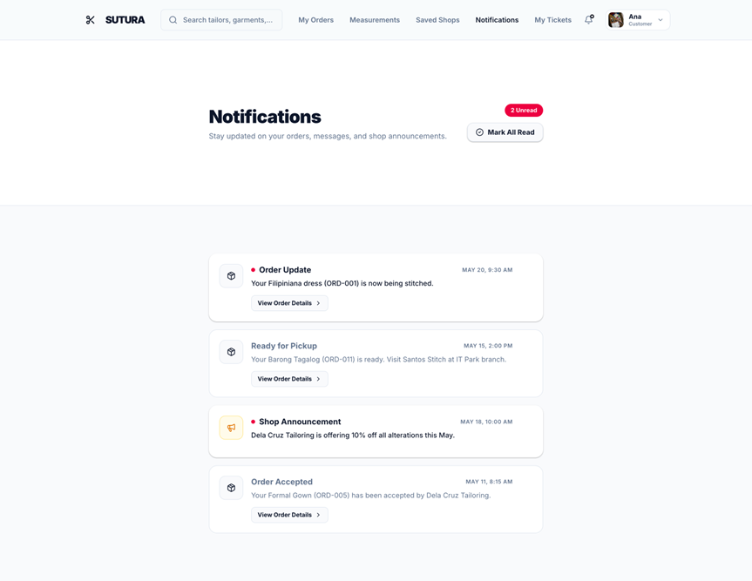
Notifications

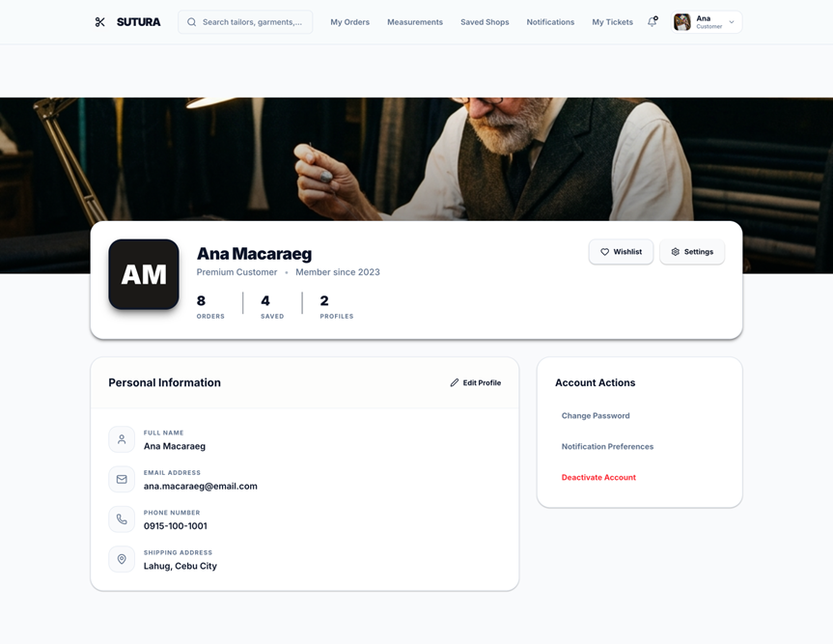
Customer Account

APPENDIX A. RESOURCE PERSONS

Francis Jade M. Solomon
Capstone Project Coordinator

Jessiel Chris D. Hilot
Capstone Project Adviser

Caressa Gauran
Tailoring Shop Owner

Curriculum Vitae of
JOSSUA A. BONGO
St. Jude, Zone 5, Buhangin District, Davao City
bongo.366031@davao.sti.edu.ph
0966 306 6583

EDUCATIONAL BACKGROUND
Level | Inclusive Dates | Name of school/ Institution
Tertiary | August 2023 - Present | Sti College Davao
Vocational/Technical | April 2020 | Assumption College of Davao
High School | April 2018 | Bernardo D. Carpio National Highschool
Elementary | March 2014 | San Isidro Elementary School

PROFESSIONAL OR VOLUNTEER EXPERIENCE
Inclusive Dates | Nature of Experience/  Job Title | Name and Address of Company or Organization
month year | N/A | N/A
month year | N/A | N/A
month year | N/A | N/A
month year | N/A | N/A
Listed in reverse chronological order (most recent first).

AFFILIATIONS
Inclusive Dates | Name of Organization | Position
month year | N/A | N/A
month year | N/A | N/A
month year | N/A | N/A
month year | N/A | N/A
Listed in reverse chronological order (most recent first).

SKILL
SKILLS | Level of Competency | Date Acquired
N/A | N/A | month year
N/A | N/A | month year
N/A | N/A | month year

TRAININGS, SEMINARS, OR WORKSHOPS ATTENDED
Inclusive Dates | Title of Training, Seminar, or Workshop
month year | N/A
month year | N/A
month year | N/A
month year | N/A
Listed in reverse chronological order (most recent first).

Curriculum Vitae of
JOSHUA WAYMAN A. ARABEJO
Lopez Jaena St, Poblacion District, Davao City
arabejo.354357@davao.sti.edu.ph
0977 704 4683
EDUCATIONAL BACKGROUND
Level | Inclusive Dates | Name of school/ Institution
Tertiary | August 2023 - Present | STI College Davao
Vocational/Technical | June 2021 - July 2023 | Davao City National High School
High School | June 2019 - April 2021 | Davao City National High School
Elementary | June 2016 - April 2017 | Balite Elementary School

PROFESSIONAL OR VOLUNTEER EXPERIENCE
Inclusive Dates | Nature of Experience/  Job Title | Name and Address of Company or Organization
month year | N/A | N/A
month year | N/A | N/A
month year | N/A | N/A
month year | N/A | N/A
Listed in reverse chronological order (most recent first).

AFFILIATIONS
Inclusive Dates | Name of Organization | Position
March 2026 - Present | Armonyx ClubVice | President External
September 2026 - Present | Supreme Student Council (SSC), STI College | DavaoAuditor
month year | Philippine Society of IT Students (PSITS) | Member
month year
Listed in reverse chronological order (most recent first).

SKILLS
SKILLS | Level of Competency | Date Acquired
N/A | N/A | month year
N/A | N/A | month year
N/A | N/A | month year

TRAININGS, SEMINARS, OR WORKSHOPS ATTENDED
Inclusive Dates | Title of Training, Seminar, or Workshop
month year | N/A
month year | N/A
month year | N/A
month year | N/A
Listed in reverse chronological order (most recent first).

Curriculum Vitae of
CLAREYNZ JUNE A. MASUDOG
Block 34, Lot 1, Daffodil St. Country Homes Phase 2, Brgy Cabantian, Buhangin, Davao City
masudog.360301@davao.sti.edu.ph
0916 854 1955
EDUCATIONAL BACKGROUND
Level | Inclusive Dates | Name of school/ Institution
Tertiary | August 2023 - Present | Sti College Davao
Vocational/Technical | August 2021- May 2023 | Starchild Innovative Learning Academy
High School | July 2017 - May 2021 | Starchild Innovative Learning Academy
Elementary | June 2012 - May 2017 | Starchild Innovative Learning Academy

PROFESSIONAL OR VOLUNTEER EXPERIENCE
Inclusive Dates | Nature of Experience/  Job Title | Name and Address of Company or Organization
month year | N/A | N/A
month year | N/A | N/A
month year | N/A | N/A
month year | N/A | N/A
Listed in reverse chronological order (most recent first).

AFFILIATIONS
Inclusive Dates | Name of Organization | Position
month year | N/A | N/A
month year | N/A | N/A
month year | N/A | N/A
month year | N/A | N/A
Listed in reverse chronological order (most recent first).

SKILLS
SKILLS | Level of Competency | Date Acquired
N/A | N/A | month year
N/A | N/A | month year
N/A | N/A | month year

TRAININGS, SEMINARS, OR WORKSHOPS ATTENDED
Inclusive Dates | Title of Training, Seminar, or Workshop
month year | N/A
month year | N/A
month year | N/A
month year | N/A
Listed in reverse chronological order (most recent first).

Curriculum Vitae of
RENALYN C. BULOTANO
Zone 1 Bagong Buhay Vill. Brgy Paciano Bangoy, Agdao, Dacudao, Davao City
bulotano.349511@davao.sti.edu.ph
0955 114 2060

EDUCATIONAL BACKGROUND
Level | Inclusive Dates | Name of school/ Institution
Tertiary | August 2023 - Present | STI College Davao
Vocational/Technical | June 2021 - July 2023 | Davao City National High School
High School | June 2017 - April 2021 | Davao City National High School
Elementary | June 2012 - April 2017 | San Roque Central Elementary School

PROFESSIONAL OR VOLUNTEER EXPERIENCE
Inclusive Dates | Nature of Experience/  Job Title | Name and Address of Company or Organization
month year | N/A | N/A
month year | N/A | N/A
month year | N/A | N/A
month year | N/A
Listed in reverse chronological order (most recent first).

AFFILIATIONS
Inclusive Dates | Name of Organization | Position
month year | N/A | N/A
month year | N/A | N/A
month year | N/A | N/A
month year | N/A | N/A
Listed in reverse chronological order (most recent first).

SKILLS
SKILLS | Level of Competency | Date Acquired
N/A | N/A | month year
N/A | N/A | month year
N/A | N/A | month year

TRAININGS, SEMINARS, OR WORKSHOPS ATTENDED
Inclusive Dates | Title of Training, Seminar, or Workshop
month year | N/A
month year | N/A
month year | N/A
month year | N/A
Listed in reverse chronological order (most recent first).

